MAY1735
ISU Department of ECprE
Dr. Daniels

Kyle Fischer - Team Lead
Michael Linthicum - Communications Lead
Daniel Shauger - Concept Holder Lead
Sam Neff - Webmaster
Nick Juelsgaard - Schedule and Planning Lead

may1735@iastate.edu
http://may1735.sd.ece.iastate.edu/
Revised: 4/23/17

CyMote for CprE 185
Final Report

Contents
Contents 1
1 Introduction 3
1.1 Project statement 3
1.2 Purpose 3
1.3 Goals 3
2 Deliverables 4
3 Design 4
3.1 System specifications 4
3.1.1 Non-functional 4
3.1.2 Functional 4
3.2 Design/Method 5
3.2.1 Hardware Design 5
3.2.2 Hardware Implementation 7
3.2.3 Software Design/Implementation 17
3.3 Design Analysis 19
3.3.1 Fall Semester 19
3.3.2 Spring Semester 20
4 Testing/Development 21
4.1 Interface specifications 21
4.2 Process 21
4.2.1 Alpha Model 21
4.2.2 Beta Model 21
4.3 Test Results 23
4.3.1 Distance 23
4.3.2 Throughput 23
4.3.3 Multiple BLE 23
4.3.4 Robustness 23
4.3.5 Battery Life 23
5 Conclusions 25
6 References 26
7 Appendix 27
7.1 Operation Manual 27
7.2 Alternative Designs 30
7.2.1 CyMote 1.0 30
7.2.2 CyMote 2.0 31
7.2.3 CyMote 3.0 32
7.2.4 CyMote Next Gen 32
7.3 Other Considerations 33
7.3.1 Bluetooth Low Energy (BLE) vs. Bluetooth 33
7.3.2 Switching from the LSM9DS0 to the LSM9DS1 34
7.3.3 Issues with Atmel 34
7.3.4 Developing on Arduino 35
7.3.5 The Practicality of Building a CyMote 35
7.4 Code 37
7.5 Circuit Documentation 38
7.5.1 Circuit Diagram 38
7.5.2 PCB Layout (Copper Top) 39
7.5.3 Bill of Materials 40

1 Introduction

1.1 Project statement
CprE 185 currently utilizes a device called the Arduino Esplora. The Esplora is a handheld controller with a simple set of I/O on board, including some buttons, a joystick, Bluetooth, and, most importantly, a three dimensional accelerometer. The students in CprE 185 collect real-world data from the Esplora to solve interesting programming and physics-based challenges. Unfortunately, the Esplora has been discontinued.
Our Senior Design group will design and build a beta model for a new device for CprE 185 specifically designed for this class. This new device, called the CyMote, will provide all the functionality previously provided while costing less. The design will be on a PCB with student generated control code.

1.2 Purpose
The department has specifically designed CprE 185 to challenge freshmen students to think like engineers. It is important for students to associate the work they do in class to solving problems in the real world. The Esplora was that connection. It allowed both user input in the form of the joystick and buttons, but it also allows for collection of the effect of the laws of physics through the accelerometer.
The device that we develop will allow students a meaningful pathway into solving real-world problems. This device will reliably provide the desired I/O, withstand constant handling, and be easy enough for a freshman student to figure out. The three main tenants of the project design are:
- Reliability
- robustness
- Simplicity for End User

1.3 Goals
The goal of the project is to create a beta model of a demonstrably robust CyMote device that will be capable of all required functions. Our hardware goal is to become proficient enough with MultiSIM and UltiBoard to create a usable, defect free, PCB. This controller must be easy for a TA or graduate student to purchase, assemble, and test. The device must have an easy to use programming interface and on-board I/O to allow testing.
Our software goal is to create easily adjustable code for the MCU. We will be providing a copy of the source code with enough internal commenting that a junior/senior level computer engineering student will be able to follow the code logic. There will also be a PC wrapper program that can be specifically tied to individual CyMotes to allow multiple CyMotes to work together in the same room. The PC wrapper program will take the data from the CyMote over BLE and present it to the CprE 185 student in a way that they can use C code to manipulate.

2 Deliverables
There are three main deliverable items for this project: (1) A physical beta model of the CyMote for display and presentation, (2) a PC wrapper that will provide a student with information from the CyMote for use in class, and (3) a full set of documentation that will allow future development.

3 Design
The CyMote will emulate the Arduino Esplora in all facets that pertain to the CprE 185 class. The CyMote will be loaded into a soft casing and be dropped from the third floor of the Coover Atrium. This is the main use case. The CyMote will be self-powered and will send info back to a computer over BLE. It will send enough data fast enough for the students to get see visibly how the acceleration of the device is affected by the drop and the landing.

3.1 System specifications
The beta model of the CyMote will be laid out on a PCB. It will use the ATSAMB11 to control various peripherals. The peripherals used are:
- Joystick with button
- 4 buttons
- Power Switch
- 9° of Freedom sensor
- 3.7V Battery
- RGB LED
The software component will be written in C using Atmel Studio and ASF project structure. There will be a wrapper program on the CyMote’s corresponding PC. This program will be a Windows executable. The wrapper will handle communication with the CyMote and will present the desired information to the student in the command line.

3.1.1 Non-functional
- Look like a game controller
- Stream data in real time – fast enough to register current movement on screen as having no lag
- Beta model built on a handheld size PCB
- Permanently securable to the PCs in the CprE 185 lab to ensure they do not “walk away”

3.1.2 Functional
- Droppable – survive a 30’ drop in a soft container of some kind
- Robust enough to have people plugging/pressing/slamming/charging often
- Communicate with a partner PC over Bluetooth wirelessly
- Low power consumption from onboard rechargeable batteries
- I/O components
  - 9° of Freedom – 3D accelerometer
  - Joystick – (x,y analog inputs, button press)
  - 4 game controller style input buttons
  - Status LEDs for all the devices
  - Tricolor LED for display/status/fun
- Power on/off switch
- Eight hours of battery life
- Communicates without loss or bugs over USB and BLE
- Streams >30 accelerometer records per second
- Permanently named (physical, BLE, code) for paring with computers

3.2 Design/Method
We divided this project up into several phases over the course of our two semesters of work. The first semester we divided into picking parts, constructing an Alpha model, and writing simple “Hello World” programs to interact with all of the peripherals. The “Hello World” programs and the Alpha model serve the purpose of verifying that all components will be able to work with one another.
The second semester was split up into designing the PCB Beta model, writing more complete programs to interact with the peripherals, writing the PC Wrapper, and documentation and presentation preparation.
Throughout the entirety of this project, we organized ourselves hardware and software teams. The hardware team had their own work sessions separate from the software team, and the software team had their own work sessions separate from the hardware team. We met together as a complete team once a week for our planning and review meetings to discuss what each team had accomplished and if they needed anything specific from the other team. Occasionally we would hold work sessions with the entire team to accomplish tasks that closely entangled hardware and software or in cases of final and intermediary documentation. Examples of such work sessions included loading and testing software on the PCB Beta models, constructing a final Alpha model for the end of first semester presentation, end of semester documentation, etc.
The three person software team divided amongst itself the three main components of the board. Each member had a specific peripheral or peripherals assigned to him. One member was in charge of the 9° of Freedom sensor, one was in charge of the physical I/O (Joystick and buttons), and the other was in charge of the BLE communication between the ATSAMB11 and the PC. This organization held for the majority of the year until work began on the PC Wrapper, where two group members began to focus on its development and the other began focusing on documentation.

3.2.1 Hardware Design
The hardware design is driven by several key factors:
- Battery life
- Compact physical design
- ATSAMB11 controller
- 9° of Freedom I/O device
- BLE transmission
- SPI communication
- User-friendly design, others must be able to re-create
We took all of these concepts into account as we designed our CyMote PCB.

3.2.1.1 MCU
Because the ATSAMB11 fits our project so well, the circuits are significantly simplified. The MCU can accept input voltages from 2.3V to 4.3V, which is more than the full range of typical 3.7V Li-Ion batteries anyway. This dovetails with our decision to purchase a single 3400 mAh Li-Ion battery for each CyMote. We can power the MCU directly from the battery with some simple voltage detection to set up an elegant death for the controller when it is near the regulator dropout voltage. Because we specifically chose the rest of the components to work on 3.3V, we can supply a 3.3V rail with a LDO switching regulator that will operate efficiently.
Because the typical current from the battery to supply the MCU is so low (even under constant BLE Rx/Tx conditions) we are able to specify a battery that does not have to be terribly large. In fact, if we take into account current draw from the 9° of Freedom sensor, and the leak currents through the joystick, and even if we assume that we will be turning on the LEDs nearly constantly, the total current draw we expect is less than 50mA. Theoretically, we can power this device for 60 hours on a 3,400mAh battery. We will be testing the actual longevity of the battery on a single charge, and we may resize the battery smaller if we find it acceptable.

3.2.1.2 9° of Freedom
The other main component that is non-trivial and required is the 9° of Freedom sensor. This sensor has nine total axes of sensing: 3-D accelerometer, 3-D magnetometer, and 3-D gyroscope. We have chosen the LSM9DS1 device for the CyMote. This chip is powered by 3.3V and uses at most 4.2mA of current to operate. It utilizes Serial Peripheral Interface (SPI) communication, so it was very important that we pick a controller that was capable of communicating over the SPI bus. Atmel chips are well suited for this bus, and the ATSAMB11 can actually manage two unique SPI buses.

3.2.1.3 PCB
Because we were able to find such well-fitted components, we were able to scope in PCB design. The PCB will contain all the components and provide a stable location for the joystick and buttons for user operation. There are some important design rules that we are taking into account in special regards to the ATSAMB11. Because of the sensitive and low-energy nature of the BLE communication protocol, the board must be specifically cut and designed to avoid any noise that might interfere with the antenna. To this end, we will ensure that the only very noisy device: the LDO voltage regulator is placed sufficiently far from the BLE antenna. Atmel also suggests that the board is physically cut to help facilitate the communication.

3.2.1.4 Battery Charging and Power Management
To provide the necessary power for our system, we need a battery. We found that a Li-Ion battery was more than sufficient for our design. Because the ATSAMB11 can take a large range of input voltages and we only need one dedicated voltage rail at 3.3V, we have chosen a 3.7V Li-Ion battery. The battery will charge at a value of 4.2V via a yet-to-be picked charging IC.

3.2.1.5 System One-Line
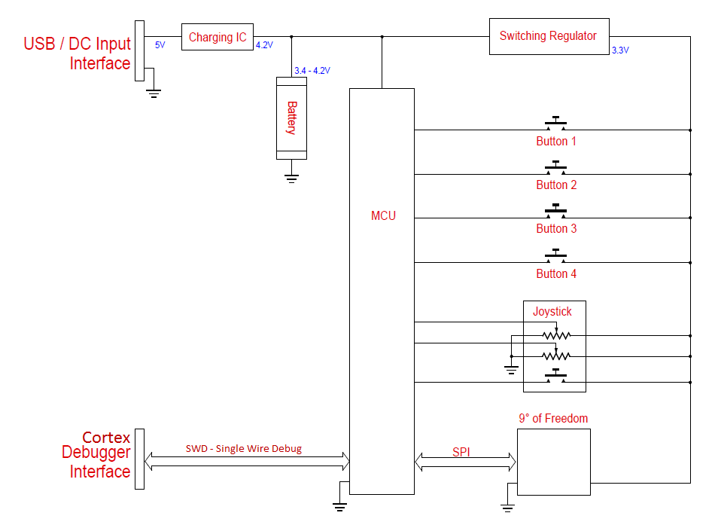
Figure 1: One-line Diagram of the system
This is our proposed one-line diagram of the system. You can see that the components are powered by the internal battery, which is in turn powered by either a USB or 5V DC interface. The MCU is directly powered by the battery while the rest of the components tap into a regulated 3.3V rail. The MCU talks to the PC over the internal BLE connection and also through a special Atmel programming/debugging interface called In-System Programming (ISP) that communicates over the SPI bus. The 9° of Freedom also communicates on this bus.

3.2.2 Hardware Implementation
The implementation of the hardware follows closely our design intentions. We wanted a compact PCB that contained all necessary I/O and a case that was handheld in size and video game-esque in appearance. While the details of the CyMote are more refined, the only thing we added that was not originally planned for was an external header for all the spare I/O and several status LEDs to alert the user about the state of the device. Note* The datasheets for all parts are available in the documentation folder on the Cybox. Documents\Hardware\Hardware Datasheets.

3.2.2.1 Plastic Case
The case for the PCB was always going to be optional, as the Esplora does not have a hard case. But as we progressed through the PCB design process, Lee suggested that we start with a case. His advice was that if we started with a case that had pre-drilled mounting studs, it would be easy to design a board that fit onto those mounting studs. So we found a case that would be appropriately sized after laying out a tentative board size. The case gives the whole project a sense of completion, and is important for the design because it gives us a place to put the buttons, keeps the battery safe, and allows the user to put it in bigger softer case for the drop. The case we picked also allows for the USB cable to fit in and charge the board. The face of the case is also where we mount our buttons and power switch. We recommend that in the future someone use the CAD files that we have included in the documentation to create a 3D version of the board in order to layout where the buttons, switches, and joystick punch through the front of the case. This will allow for an easier machining process.
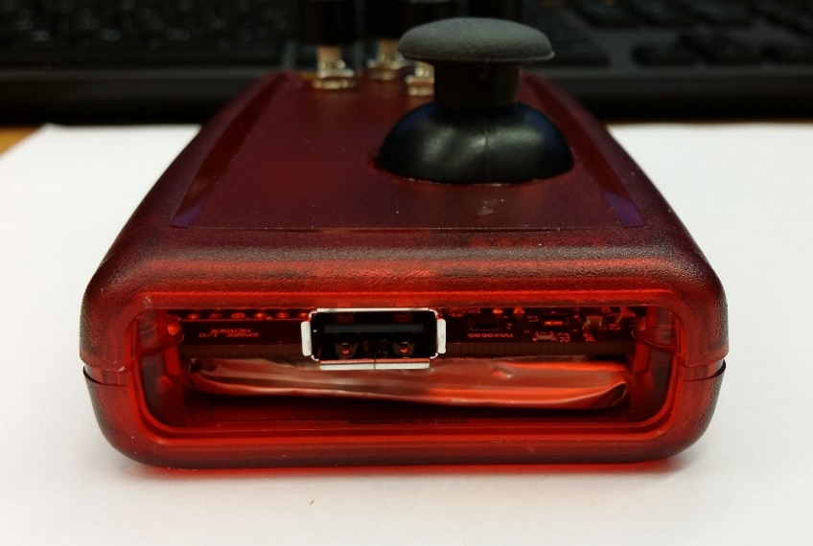
Figure 2: CyMote Case

3.2.2.2 Printed Circuit Board (PCB)
The PCB is most important piece of the puzzle on the hardware side. During the design process, we had three distinct designs. We took a lot of info and advice from Lee Harker throughout the process, but he especially helped us get our first PCB set up. We set up for 6 mil traces, 6 mil spaces, and a copper pour everywhere there was not traces. Our standard via size is 15 mil hole diameter 25 mil pad diameter. We used a standard two-layer board with a copper layer on top and bottom.
We had specific accommodations for the ATSAMB11. The best way to make space for the antenna is to set the ATSAMB11 off the board a little. However, we wanted the ATSAMB11 to be a little safer, so we kept it inside the rectangular confines of the board and cut out a hole big enough for the antenna to fit without any communication disturbances. There are many considerations for the board driven by individual devices, which we will talk about in their individual sections.
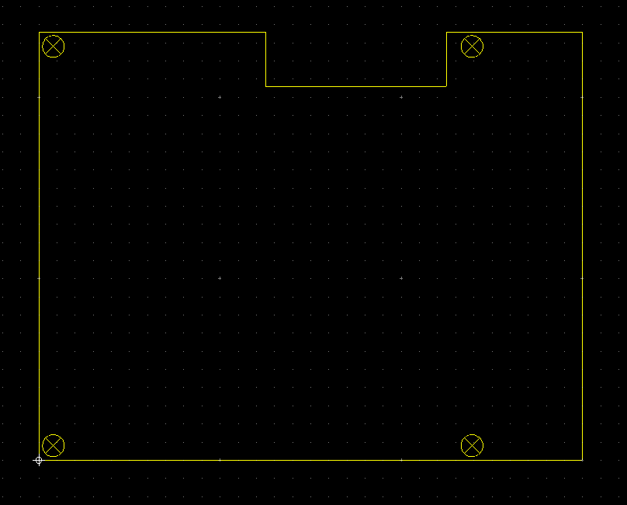
Figure 3: Outline of the PCB
We used several standard resistors and capacitors on the PCB. We wanted every mounted to the front of the board in a surface-mount style. It is much easier to reflow all these parts instead of solder them by hand. All parts are Package 0805 (if they can be). 0805 is a standard part size that is 80 mil wide and 50 mil tall. Most resistors, capacitors, and LEDs are available in this package size. Several of the parts are very tiny, so even surface mount solder pasting is not a walk in the park, but it is much easier than the alternative. For all the quad flat package devices we designed the board pads to extend beyond the edge of the piece about as far as the pads were long. This allowed us to reach of the solder points and remove ICs if we needed. We had to custom design the pad layouts for most of the ICs, and you can find these parts in the User Database connected to the design files.

3.2.2.3 MCU
The king of the board. The main considerations for the PCB were the cutout for the antenna and the vias to minimize the interference. But the layout of the rest of the parts were driven by the placement of the ATSAMB11. There are 40 pins on the ATSAMB11: several ground pins, a couple 3.3v pins, one input power pin (battery voltage), and over two dozen I/O points. The I/O points are all extremely versatile, as most can be internally multiplexed to several types of I/O, including a changeable GPIO. But even more impressively, most pins can be multiplexed to point to another multiplexer called the MEGAMUX. The MEGAMUX can be tied to just about any signal on the board. The variety of choices is amazing.
The ATSAMB11 is powered by the system output line of the battery charger. This voltage is tied to the battery voltage, as it has its own internal power management chip. The efficiency of the internal power chip on the ATSAMB11 is better than then voltage regulator, so we let it take care of itself. The input voltage requirement of the ATSAMB11 is wider than the available voltages from the battery, so as long as the battery will ‘stay on,’ the ATSAMB11 will be powered. There is also a ground pad on the bottom center of the chip, so when we built the board we had to make sure that pin was soldered to ground. An important part of the chip is the 32.768 kHz RTC crystal that is connected between pins 25 and 27; it is required for controlling peripherals and internal counting.

3.2.2.4 9° of Freedom
We chose the LSM9D0 because we were given a design that included it. We were able to interpret most of the pins easily. The chip requires several very specific capacitors included a high accuracy 10nF capacitor. All of the capacitors that the chip needs were placed very near to the chip. There are several points on the board that must be tied to ground, and several points that can be left floating. Refer to the documentation to see these points. The LSM communicates with the ATSAMB11 over two SPI lines. It takes in one master out, slave in (MOSI) line and the SPI Clock generated by the master: the MCU. It returns information on two separate master in, slave out (MISO) lines that are distinctly chosen by the MCU with the two slave select (SSC) lines. Moving forward, we would like to change the two separate MISO lines to be tied together since they can be. It was a design error that was too low priority to address. Moving the line would aid confusion the code and also free up another GPIO pin. As a different solution, the second MISO line could be multiplexed into the correct pin internally in the ATSAMB11.
Unfortunately, throughout the process of designing the board, we found that the LSM9DS0 chip had become obsolete, to be replaced with the LSM9DS1. This revision from 0 to 1 was one of the major changes between the first and second iterations of the board. The pinout is almost entirely the same except that the gyroscope information is now transmitted on the accelerometer line instead of the on the magnetometer MISO.
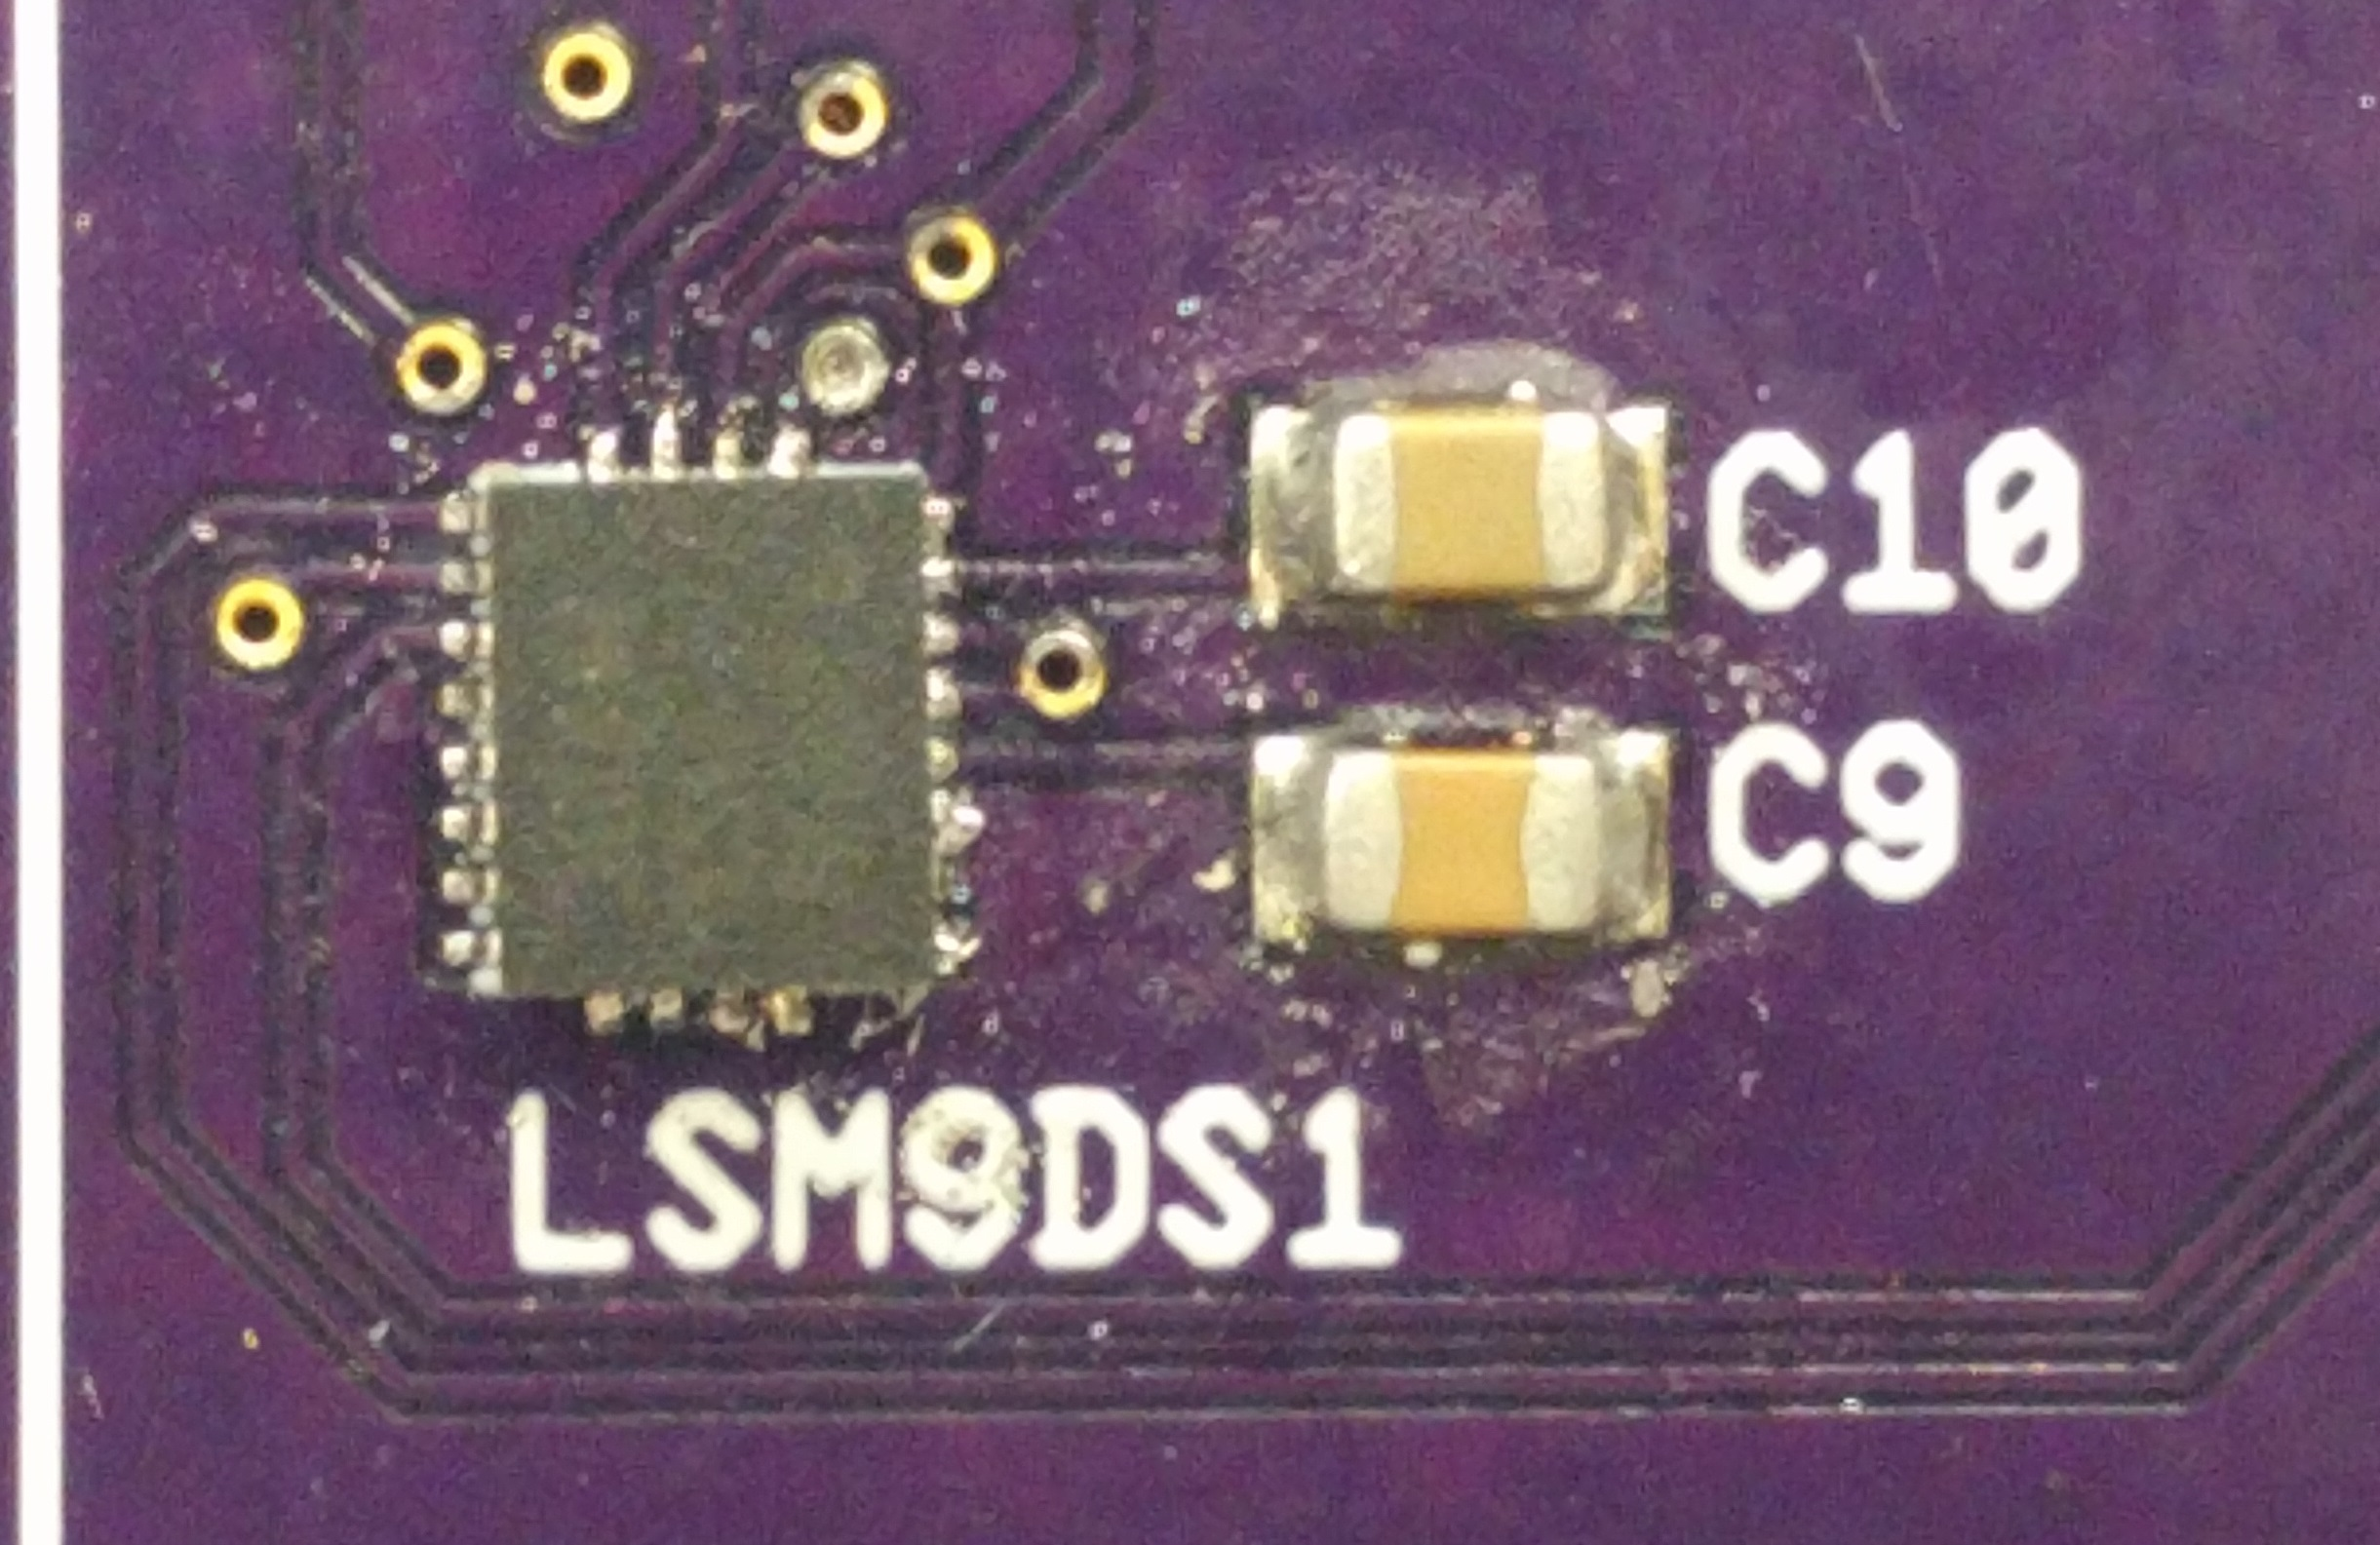
Figure 4: LSM9DS1- 9 Degree of Freedom Sensor

3.2.2.5 Battery
We originally started working with a very large cylindrical battery that has 12k mAh of charge. This battery was suggested because it had previously matched up to a design that someone else had worked on. However, it became apparently once we switched to Bluetooth Low Energy that the battery would be extremely over-sized. Once we knew what our case was going to look like, we went out to find a batter that would fit in our case. We came up with a flat style battery from SparkFun. It is still a single cell lithium battery, but it has a smaller (but still relatively large) capacity and can fit right under the PCB in the CyMote case. The only precaution is that the battery must be covered with a non-conducting material so it does not touch off on the few through-hole pins we are using that extend under the board.
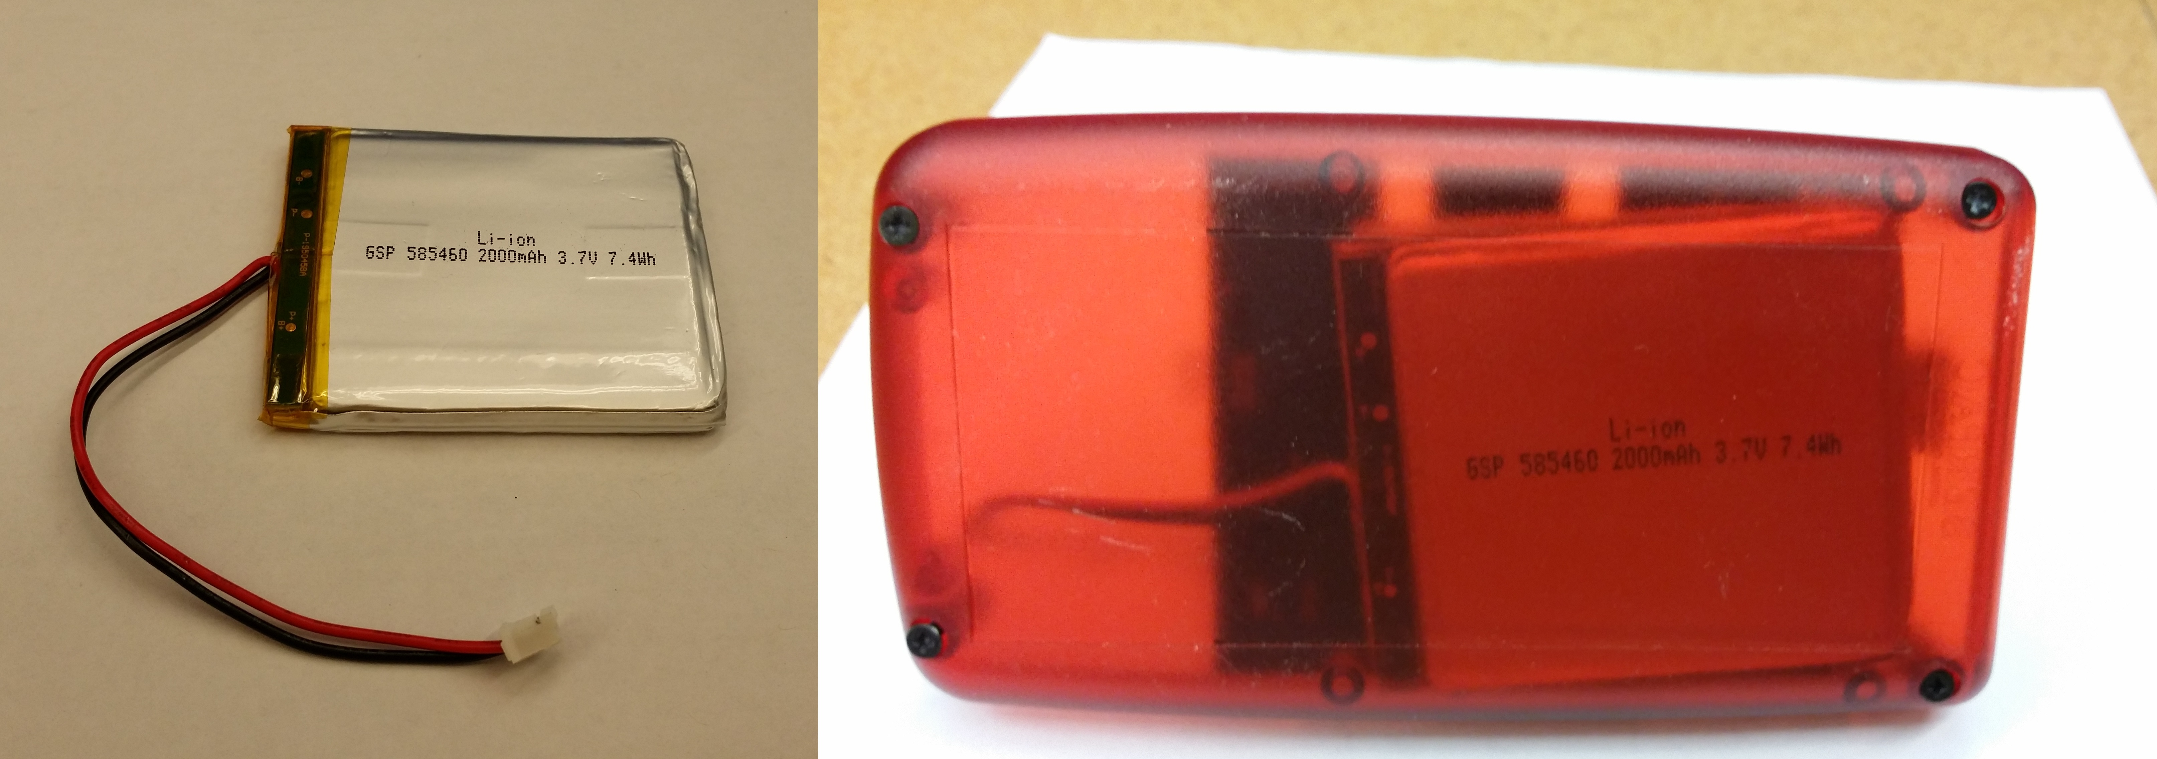
Figure 5: CyMote Battery

3.2.2.6 Battery Charging and USB Connection
We wanted a single solution for the battery charger and the voltage regulator, but we did have significant issues trying to understand all the options. We finally decided to split the components and implement the battery charger separately from the voltage regulator. We found a TI chip called the MAX8606 that will completely manage the battery, feed battery voltage to the regulator and the ATSAM, and it will also signal to the user when it is plugged in and charging. We chose to tie the enable for the chip to the input voltage, so if the battery is plugged in, the board is always ‘on.’ We also set the board to charge at 100mA because we wanted to be safe. It turns out that 100mA is not very fast for the size of battery we want. There are two other internally defined charging speeds that you can select, and you can use resistors to set a custom charge speed. We recommend staying under 500mA, but recommend a design change to increase the speed. It would be possible to add dip switches to make it real-time variable.
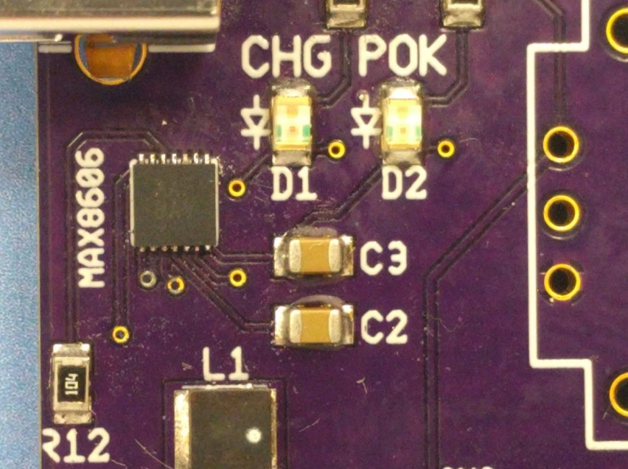
Figure 6: MAX8606- Battery Charging Chip and Status LEDs
The charging power is supplied by the USB connection. We initially wanted to have a USB-B type connector, but unfortunately we could not get a cable in the hole of the case with this type. So we switched to the USB-A type connector instead, which still gives robust usability. The only thing that the USB is providing is 100mA of 5V. If the battery is plugged in, the two LEDs will turn on. The green LED indicates that the input voltage is high enough to charge. The yellow LED indicates that the battery is currently charging. Both of these LEDs are currently powered by the 3.3V rail. Ideally, we would design these to be powered by the input voltage to the charging IC, because currently they will not turn on unless the power switch is on (even if the chip is actually charging the battery).

3.2.2.7 Voltage Regulator
The MAX battery charger IC outputs battery voltage when it is enabled, and this voltage (2.8V-4.2V) will come out of the chip and power the voltage regulator. We chose the TPS63031, a fixed output buck/boost regulator. It will manage the entire range of input voltages from the battery and output a constant steady 3.3V at a max sustained current of 900mA. This 3.3V is used by all of the I/O (LEDs, buttons, joystick), but most specifically the LSM9dS1. There are not so many design choices that this chip offers, but a very specific board layout is suggested by the manufacturer and implemented on our board.
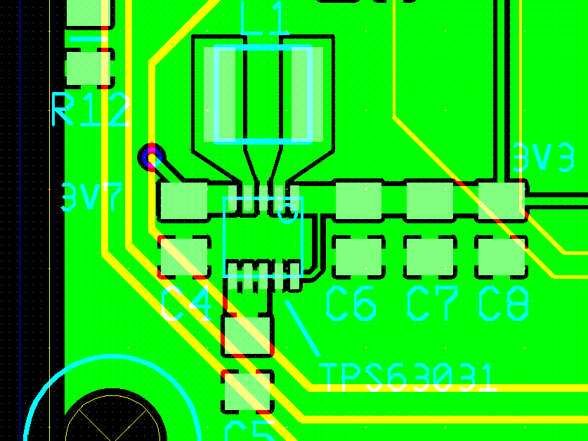
Figure 7: TPS63031 Board Layout
As you can see, these are not simple traces. All of the pads and copper runs were designed by hand. The inductor (L1) in Figure 7 above is the biggest design consideration as the size of this inductor can affect the efficiency of the regulator. There are also 5 capacitors that surround the TPS63031 to try to filter out the switching noise and cancel some of the RF noise that the TPS63031 generates. These are also designed to be as close to the board as possible. But because it does generate some noise, we have tried to keep it as far away from the MCU as possible. This minimizes the amount of RF noise that may affect the BLE antenna.

3.2.2.8 Single Wire Debug (SWD) Connection
We spent an awful lot of time trying to figure out how to program the board. We originally thought we might program the board over SPI, but we were not sure how to program a board from the box this way. Atmel suggested SWD, which can be programmed similar to JTAG with a debugger tool called the Atmel ICE. We are not experts, but the design documents for the Atmel ICE debugger suggest that you need up to 8 pins in order to program the board. The most confusing of which is the ‘Reset’ line. In the documentation and many forums online the Reset line (sometimes nReset) is present and connected to a ‘reset’ input on the MCU. However, the ATSAMB11 does not have a pin like this. After many hours, we found that there are only 4 wires that are required to program the board over SWD: Power, Ground, SWDCLK, and SWDDIO. These four pins are available via the Cortex debug header that is to the left of the board. They line up to a straight through 10 pin connector that hooks to the Atmel ICE SAM port. The silkscreen on the board indicates which way the notch should go.
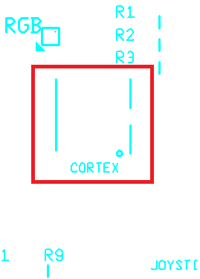
Figure 8: Cortex Orientation
We did buy some shrouded headers that will force the debugger to be plugged in only one way. We suggest that once the programming header becomes codified, that the shrouded header is used instead of the non-shrouded ones. An even loftier goal would be including a USB to UART/SWD/SPI gateway for the ATSAMB11. This way you would be able to program the device simply by hooking up the USB cable. Unfortunately, we did not have enough time to pursue this option.

3.2.2.9 External Headers
There are several important headers that we wanted to use to compartmentalize our board. The battery is plugged in with a header that matches the plug that comes standard on the battery. This allowed us to test the board easily on early iterations, and it will allow for quick and painless replacement of a bad or broken battery.
There is also a header for the power switch. The power that comes out of the charging chip is fed into this header. Post switch wire goes to the ATSAMB11 and the input for the voltage regulator. We divided it this way to allow the battery to be charged when the board is not turned on. There is also an LED by the power header that is turned on when the power switch is made. This is a 50% solution. Currently the power switch is a simple through-hole switch that is glued into the face of the case. There are many solutions that are preferable to this, and would not be difficult necessarily, just time consuming.
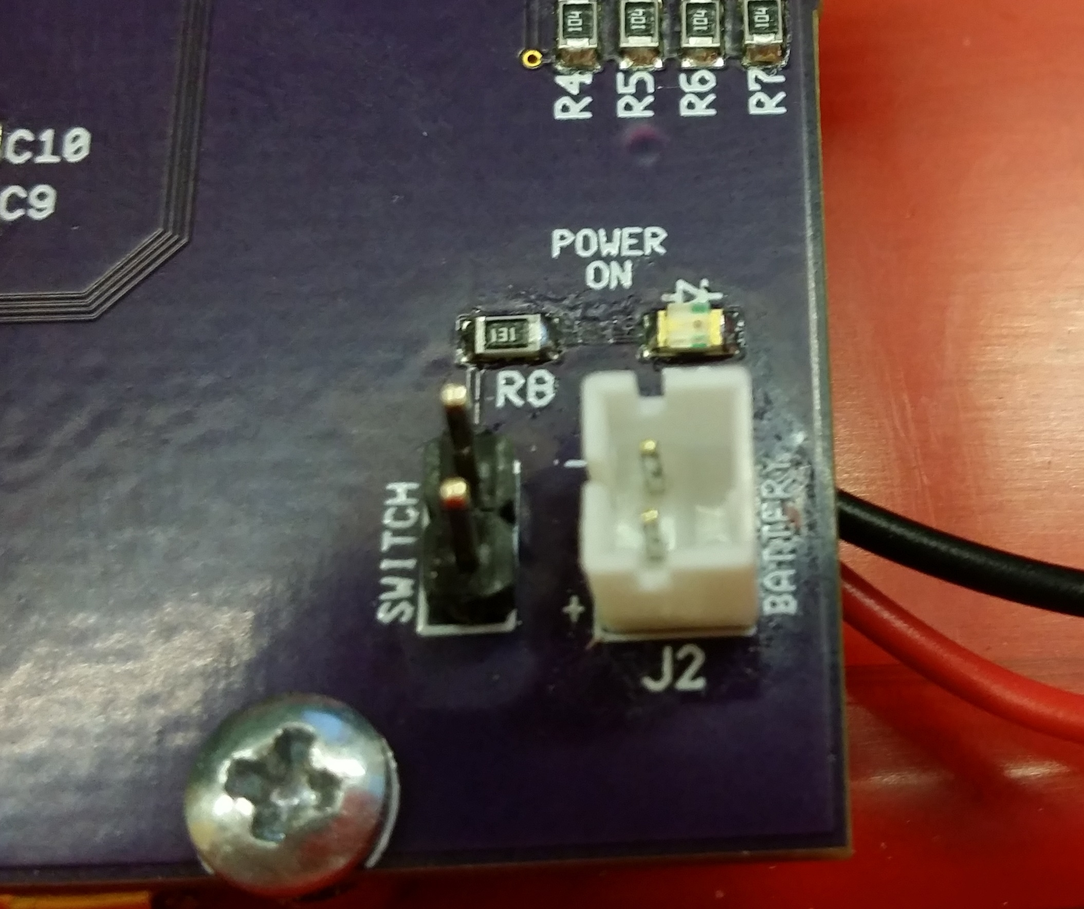
Figure 9: Battery and Power Switch Headers
There is also a header set for the buttons which are installed on the case. We are using the same spacing for these as the Cortex header. This way we are saving a lot of space on the board. Each button has a pin for power and signal on the header, and these go right to the inputs on the MCU.
At the client’s request, we designed a header to expose the spare I/O. This header is a standard 100mil spacing and it is 2 by 7 pins in dimension. All of the extra pins from the ATSAMB11 are available on this header as well as the SPI MOSI and the SPI clock.
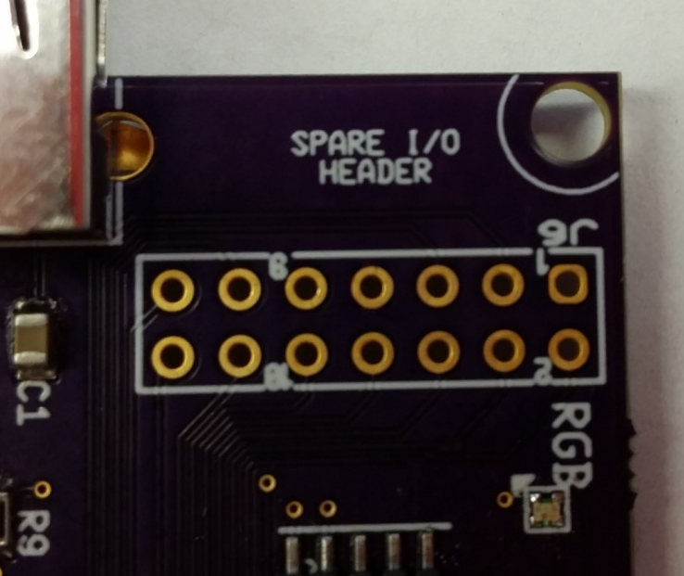
Figure 10: Spare Pin Header

3.2.2.10 Buttons
We chose the smallest panel mount buttons we could find in a short time. They are single pole, single throw (SPST) buttons. There is nothing special or fancy about them, and they could be replaced with literally any simple button with the same success. This may be easier if they are board-mounted, but if not, it will be easy to integrate them into the existing header.
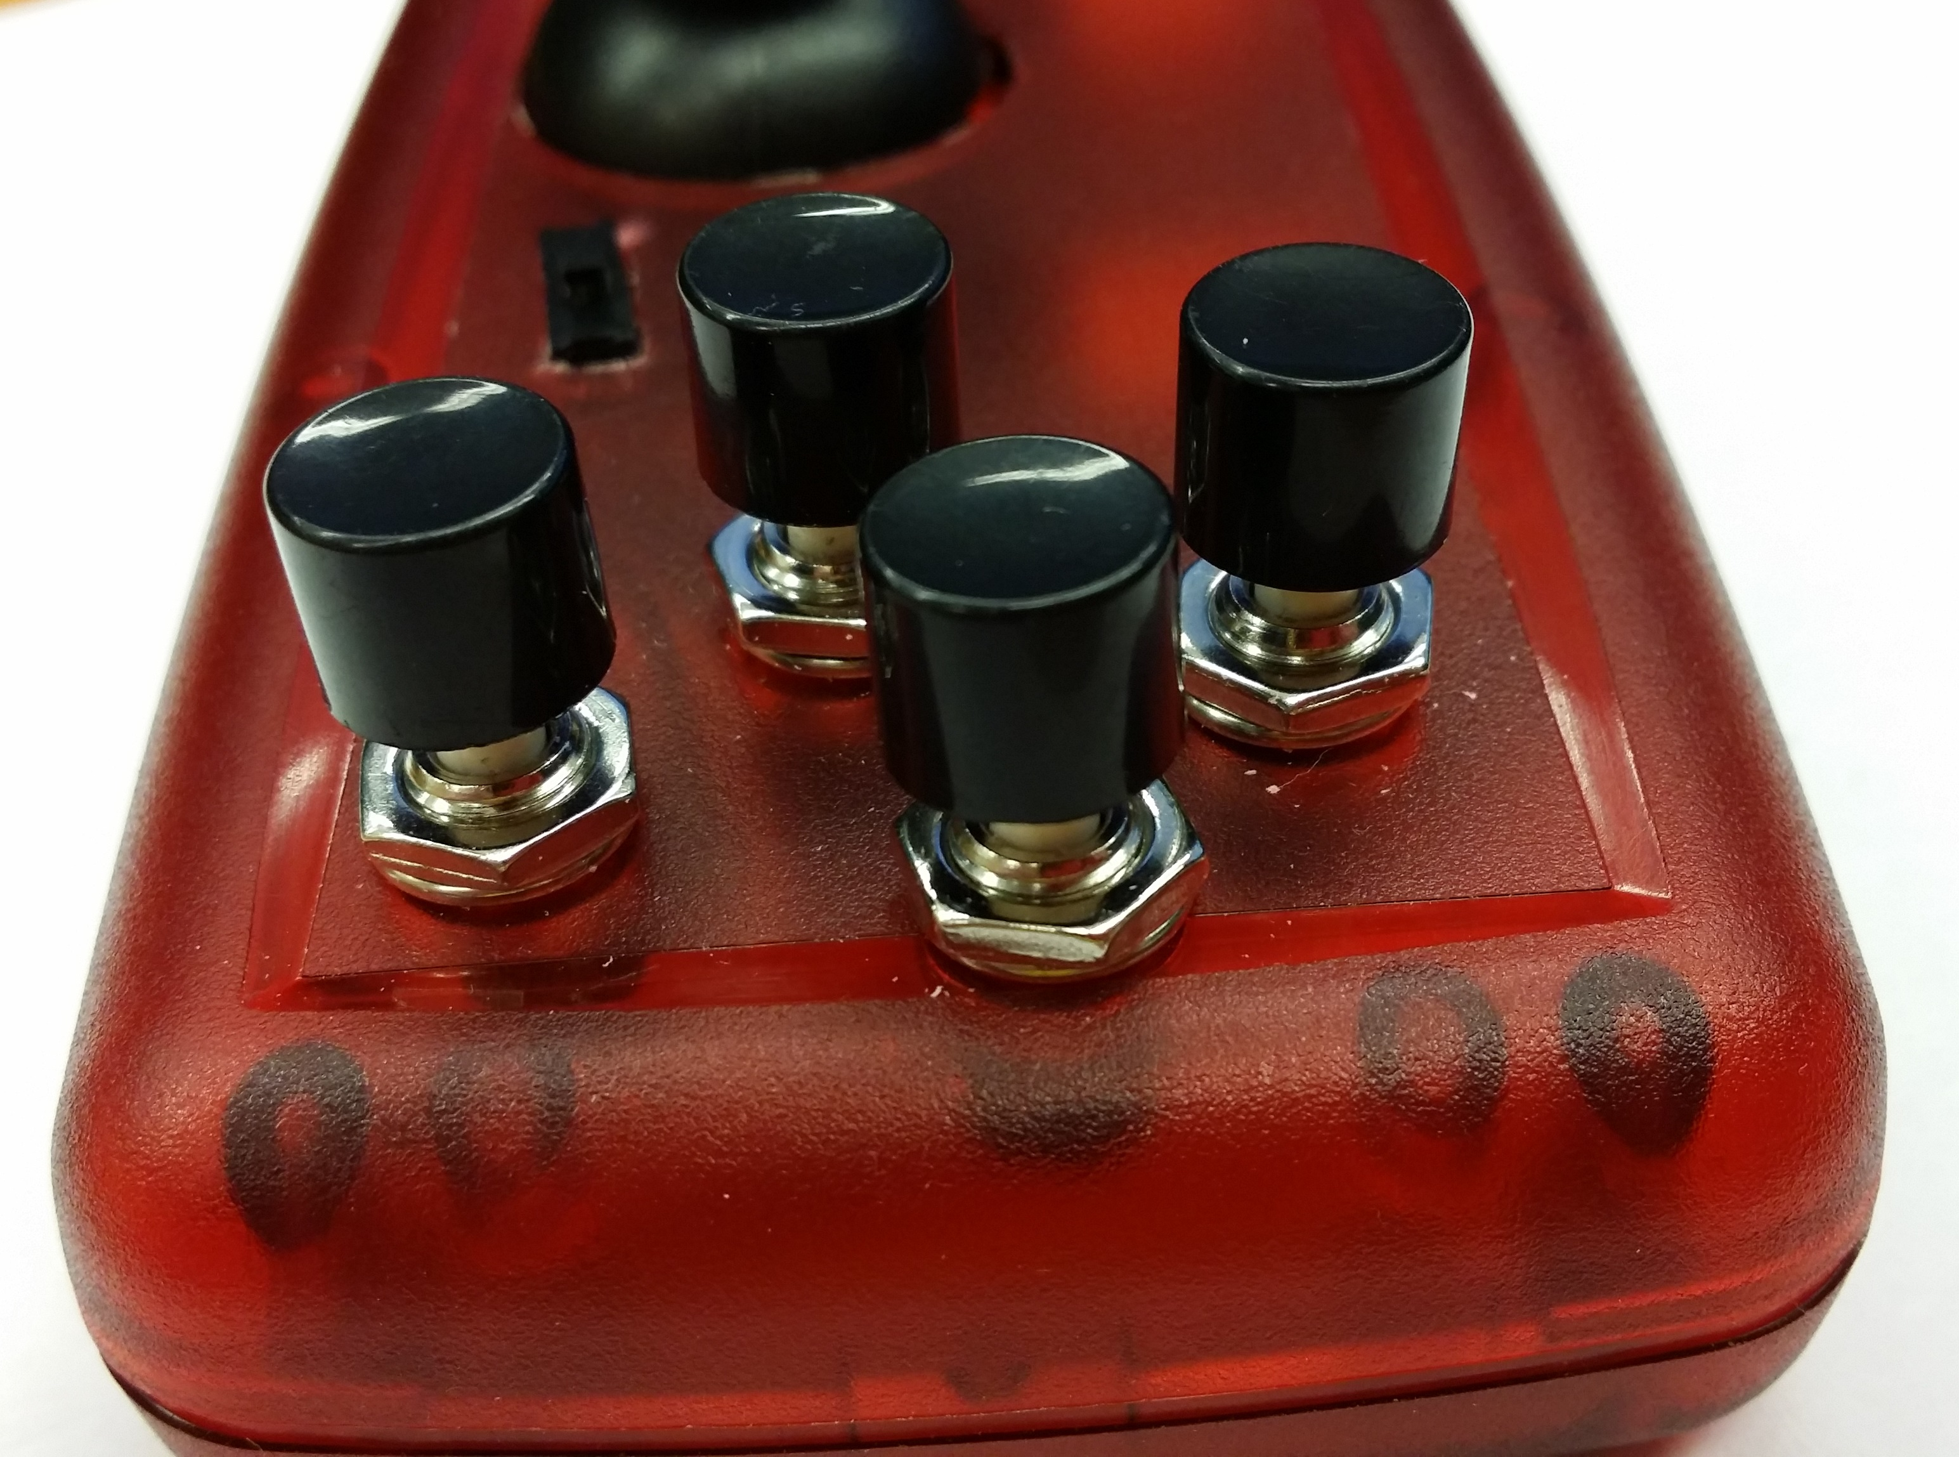
Figure 11: CyMote Buttons

3.2.2.11 Joystick
The joystick is a simple two potentiometer system, with a SPDT button incorporated. We really like the feel of this joystick. It is easy to use and integrate into the system. It has a pad layout that allows it to slide right into the board. Unlike the buttons, the joystick is an integral part of the board, and cannot be removed. This gives it a lot of rigidity, but means that we had to design a hole through the surface of the board that will accommodate the joystick. The unfortunate part is that while the joystick looks very good when it is standing straight up, the case is not quite tall enough to cover the joystick completely when it is pushed all the way in one direction. This exposes the inside of the CyMote and is not an ideal situation.
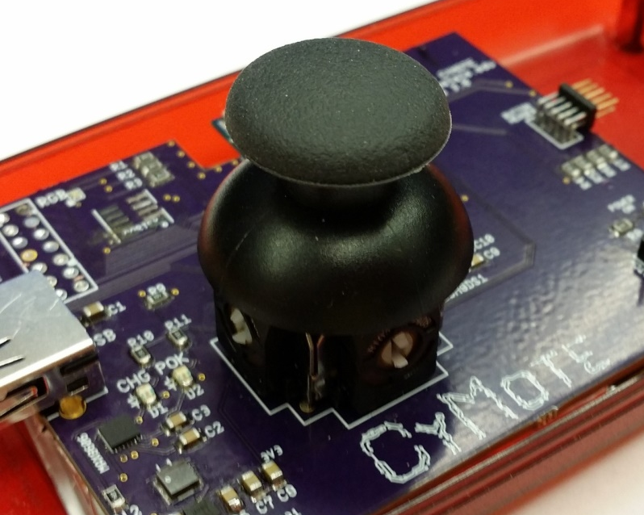
Figure 12: Joystick

3.2.2.12 RGB LED
The RBG LEDs are a simple output mechanism that we are using to allow for debugging and simple output alerting. We want a very low power RGB chip so that we were not losing the majority of our energy through the LEDs compared to the BLE. The LED we picked outputs 5mA of power for each color. The only caveat is its size. It is by far the smallest chip, and it is not the easiest piece to solder on. But the color looks good and it is definitely bright enough to see clearly.
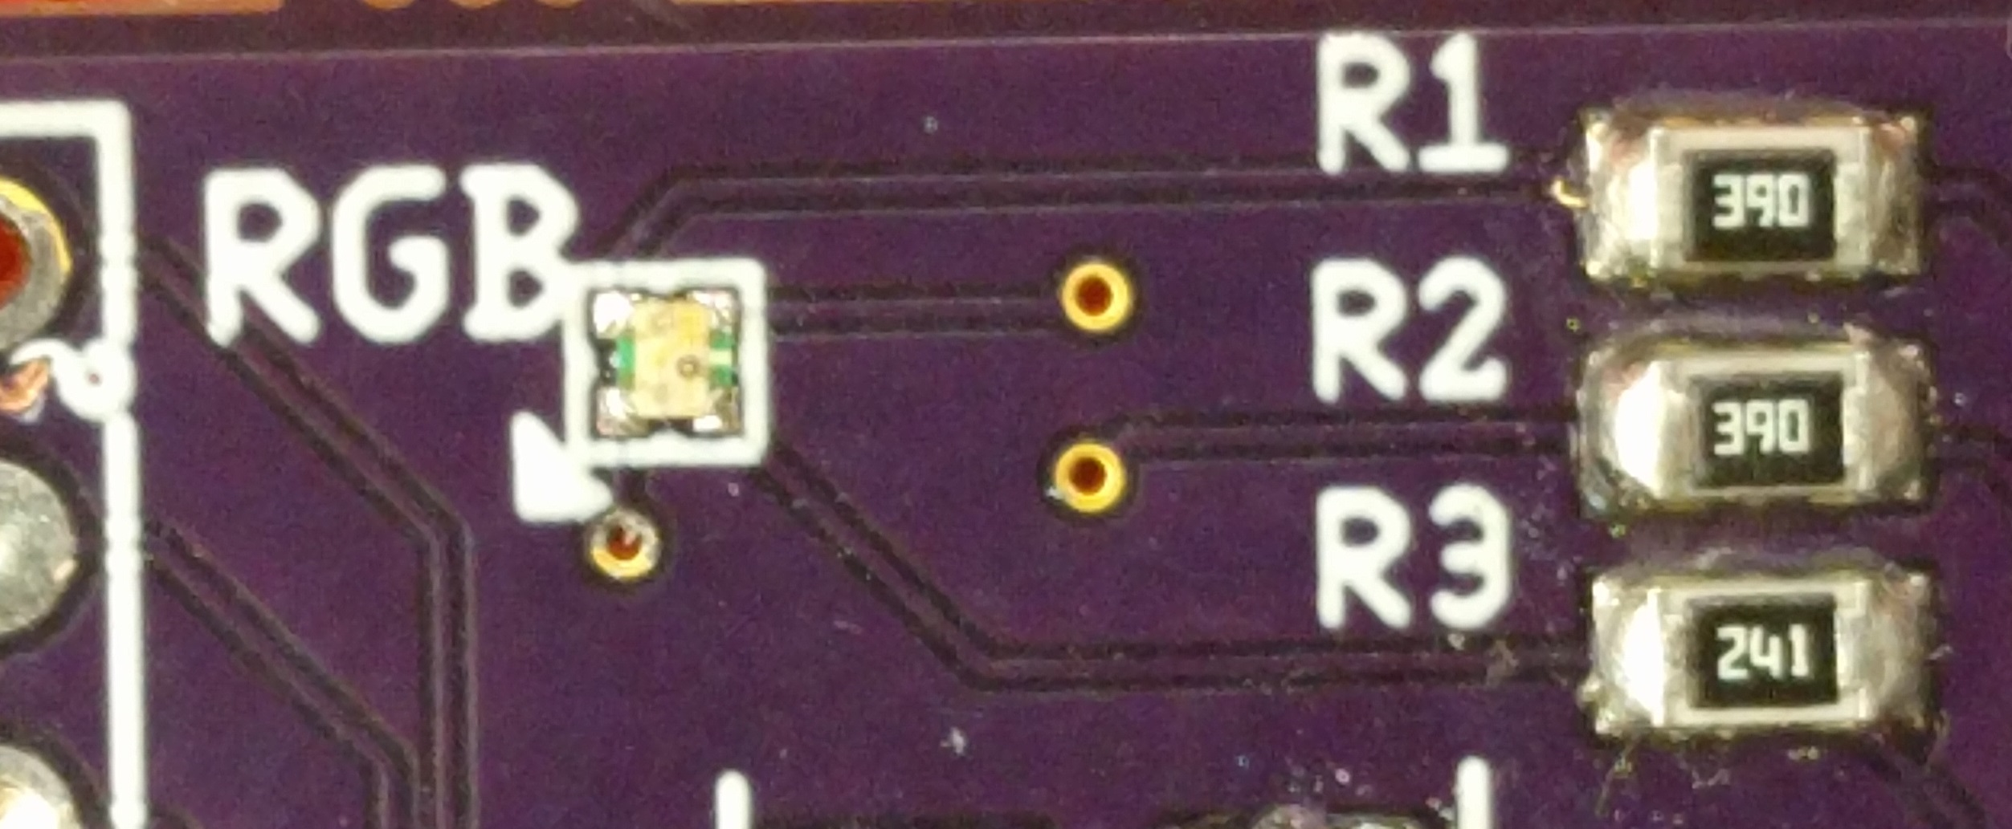
Figure 13: RBG LED and Current Limiting Resistors

3.2.2.13 Labelling
Through the iterations of the board, we included more and more silkscreen information. We included the name of each component, the outlines of every IC, and a circle for pin 1 on every board that needed it. But we found in the first iteration that we were still missing some information. So we began including diode images to make sure we put them on the right direction, and we included an arrow for the RGB LED so could orient it correctly. We also included a notch next to the Cortex debug header to allow the user to plug it in the correct way. And every iteration has had our group name, project name, and e-mail included.
And just for fun, we designed a little logo for the CyMote to include on the 3rd iteration. It was meant to look like a bunch of traces and vias.
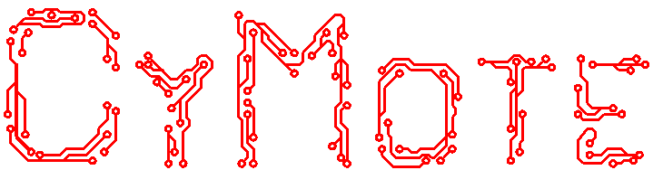
Figure 14: CyMote Logo

3.2.2.14 Documentation
For visual descriptions of the CyMote circuit diagram, see Appendix 7.4.

3.2.3 Software Design/Implementation
The ATSAMB11 will be programmed with Atmel Studio 7, which is a free software suite for programming all Atmel controllers. This will allow the future super users of the CyMote to easily update MCU code and make bug fixes and feature additions. Because of the nature of the ATSAMB11 and the SPI protocol, this system will be fairly easy to add devices to. We foresee the necessity/desire to add devices such as ADC/DAC converters and an audio codec into the CyMote, so this will make the modularity of the device very handy for future developers.
The PC wrapper program will be a Windows executable and will interface with a BLE dongle either permanently embedded in a computer or secured to the computer in some way. The PC wrapper will handle the BLE communication from the PC to the CyMote and request data only when the user wants to collect the data. This way we avoid using energy in the CyMote when it is not necessary. The PC wrapper will also handle simple error communication to the user to allow freshmen to troubleshoot the device if it is not working properly.
The CyMote itself must be able to handle all on-board devices and communicate when it is working correctly and when it is malfunctioning. We will do some significant testing to prove out reliability. Below is the basic program diagram.
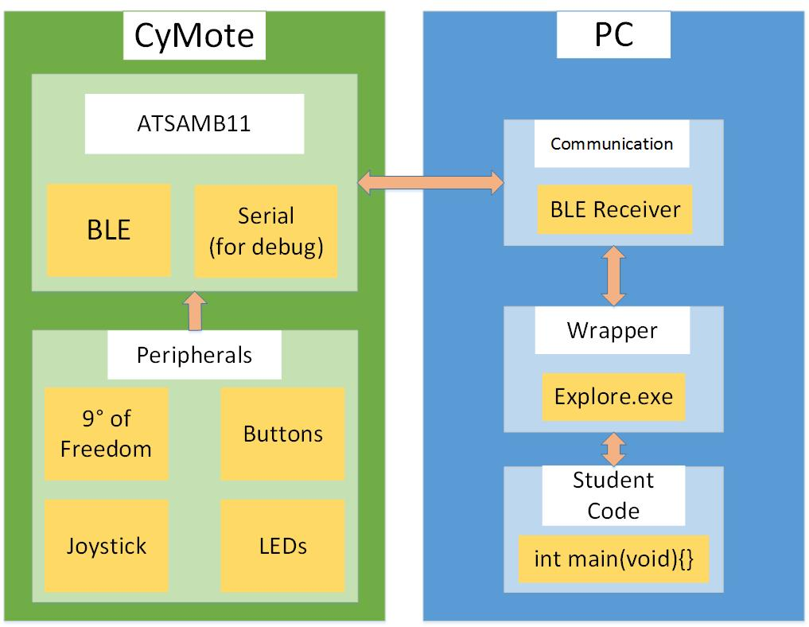
Figure 15: CyMote data flow
The two main external communication paths are the BLE communication from the BLE dongle on the PC to the ATSAMB11 BLE antenna and the debugger connection from the PC (through SWD) to the ISP programming interface on the CyMote. Each CyMote will have a permanent name that will link it to a corresponding PC and BLE dongle.

3.2.2.1 Digital and Analog I/O
The CyMote must handle the input of four game controller style buttons. These are digital inputs and the CyMote must be able to communicate these button presses to the PC as Boolean values. The joystick has two axes and a button built in. The two analog values (ranging from 0-1023) along with the digital signal of the button must also be communicated. The RGB LED is driven by PWM outputs from the device as well, and these values must be able to be set by the user.

3.2.2.2 9° of Freedom
The ATSAMB11 continuously polls data from the LSM9DS1 as fast as the SPI implementation can request it. Due to the difficult Atmel APIs, we have decided to create our own register reading and requesting implementation, a concept known as Bit Banging. We simulated the entire SPI protocol through software on variable GPIO instead of in dedicated hardware registers. The SPI protocol used by the LSM9DS1 is SPI Mode 0. This SPI mode infers that the ATSAMB11 must sample data on the leading edge of the clock cycle with a non-inverted clock.
Using a Bit Banged version of the SPI interface does mean that the data transfer is slower than it could be. However, the data transfer rates we achieved is still much faster than we required.

3.2.2.3 BLE
One of the main design concepts of this project is that our controller has to be wireless. This means that power consumption is a big issue. In order to minimize power consumption, we decided to use Bluetooth Low Energy (BLE) as our main form of communication. This low energy standard transmits less frequently than Bluetooth Classic, saving power.
We expected BLE to be similar to Bluetooth Classic in its overall approach but it turned out to be a little more complicated. BLE creates a tree hierarchy consisting of a single profile, services that part of that profile, and characteristics that belong to a service. Services can have more than one characteristic. To transfer data, the listening device has to request a characteristic from the BLE host. The host will then send the data in that characteristic to only the listener that requested it. This is vastly different from sending a byte array using Bluetooth Classic.
In the end, BLE worked but it was slow. We knew that BLE did not transmit nearly as often as Bluetooth Classic but we thought that we could implement BLE, test it, and change to Bluetooth Classic if we needed to. It took us about a semester and a half to really understand all of the intricacies of BLE and to get the project to a point where we could test data throughput from board to PC Wrapper. Because of this delay, we did not have time to implement a Bluetooth Classic module, so we exposed some GPIO to implement it later and made BLE work as fast as we could.

3.2.2.4 PC Wrapper
The PC wrapper emulates the current interface that students use to interact with the Arduino Esplora. Students are able to run the program directly through the windows command line or through a Cygwin terminal. We wrote the PC Wrapper in C# and packaged it as a Windows Executable to achieve this.
To use the PC wrapper, students simply call the program on the command line with a number of predetermined flags. These flags let the wrapper know what data it should show. These flags are single letters and are unique for the accelerometer (a), magnetometer (m), gyroscope (g), joystick (j), time (t), and buttons (b). If students provide no flags, or unsupported flags, a simple usage message is output.
To connect with the remote at a lab station, students use the Windows Bluetooth connection interface. The TA provides these instructions to the students, and the process is not complicated and should not be a hindrance to begin interfacing with the board.
The PC Wrapper also includes basic error handling for when the CyMote loses connection to the PC for one reason or another.

3.3 Design Analysis

3.3.1 Fall Semester
We spent a significant amount of the first semester finding the appropriate components, defining the scope of our project, and testing our chosen MCU.
We chose the Atmel ATSAMB11 as the controller. We purchased three development boards called the Xplained Pros, which Atmel provides to develop the project. We utilized Atmel’s startup documentation as well as some pre-designed programs to develop our BLE and SPI communication to mixed results. The SPI and BLE documentation for the ATSAMB11 was sparse and not well documented. We spent a significant amount of time debugging and deciphering Atmel’s code. If we were familiar with the documentation before beginning the project, we would have chosen to develop on a different board.
The buttons, LEDs, joystick, and 9° of Freedom sensor all work as expected and were excellent choices for our project. If we were to redesign this project, we would have decided to implement Bluetooth instead of BLE. BLE is suited for notifications and is a much more complicated interface to implement. Bluetooth is suited for streaming data and operates like a standard serial connection, which would have been much more appropriate for our needs. We chose BLE due to it being a low power protocol and we were unfamiliar with the technology at the time and with Atmel’s sparse documentation on how to use it with the ATSAMB11.

3.3.2 Spring Semester
Much of the analysis of our design has been discussed throughout this document. We evaluated the design as we went. We found that there were obvious defects in places, and sometimes there were non-obvious defects or issues with the design that were not our fault. And the nice part was that we were able to address almost all of these issues as we went on.
For our final Beta, the design matched our expectations fairly well. We were not able to get a fully functional device to the field, but we have what we feel like it is a 90% solution. The physical presence of the device fits our expectations, and the device successfully talks over wireless to a partner computer. We have proven all the pieces of our device, the place where we would prefer more time to finish is in the integration. As a project to be handed off to the next group, we feel that we have provided a great foundation that has been well documented. We have also begin to run the tests necessary to fully prove out the solution.

4 Testing/Development

4.1 Interface specifications
Students will communicate with the CyMote over BLE using our PC Wrapper, explore.exe. They will not load code directly on to the board, they will simply interact with the data pulled from the board with their own programs they write and run on the lab PC. The Atmel ICE debugger connected to a PC via USB and connected to the CyMote via a SWD connection is used to program the ATSAMB11. This interface should not be used by CprE 185 students. To charge the device, connect it to a power source over a USB connection.

4.2 Process

4.2.1 Alpha Model
The Alpha model served as a medium for us to learn and to test our picked parts. We spent a significant amount of time in this phase of our project determining what parts we would use and learning how to interface with them. Much of our time was spent individually researching and sharing our findings during the weekly group meetings.
Once the parts were picked out we ordered them and began interfacing with them. Again, most of this work was done individually and progress was shared during meetings. Simple “Hello World” program parameters were defined by the entire team and it was up to the software member in charge of that peripheral to implement it. The hardware team, at this point, worked on building the overall schematic and design files of a constructed alpha model. They researched charging chips, battery power, possible plans for a PCB, and voltage regulation methods.
This work plan continued until near the end of the first semester. When the “Hello World” programs were written, parts were picked, and significant research and design had taken place on the hardware side, the software team and hardware team began working heavily together to construct the Alpha model. The software team compiled their individual “Hello World” programs into one large Alpha program, and the hardware team finished their schematic designs, constructed a charging circuit and a battery circuit, and constructed the physical Alpha breadboard model.
Small tests were run and we verified that we were able to communicate with the MCU, talk to the 9° of Freedom sensor over SPI, get feedback from the buttons through LEDs, and control an RGB LED with a joystick. At this point, BLE had not been implemented as we were having development issues related to sparse Atmel documentation and unforeseen BLE overhead.

4.2.2 Beta Model
The Beta model is to be our final product. It is not meant to be ready for the classroom, but ready for continued development and optimization either by a research group or interested student over the summer, or by an entirely new senior design group.
During development of our Beta model, the software team further developed their “Hello World” programs into fully functional drivers for their respective peripherals. They also began extensive work on BLE functionality and the PC Wrapper. The BLE interface proved to be more difficult than initially expected due to sparse Atmel documentation and significant configuration overhead. The tested data transmission rate ended up being much slower than required with BLE, and Bluetooth should be considered for further development of this board. Development of the PC Wrapper also took place during the Beta phase of our project. We decided to make the PC Wrapper emulate the current CprE 185 Esplora interface as much as possible, so we defined our requirements as such.
This phase of the project also involved fabrication of a PCB. The hardware team focused solely on this requirement during the second semester. Neither hardware team member had prior experience designing the PCB, so they initially reached out to various faculty members for guidance and continued to collaborate with them for the duration of the semester. We went through three iterations of our PCB. The first iteration failed due to an incorrect reference diagram found in the ATSAMB11 datasheet. The datasheet showed inconsistent pin configurations of the ATSAMB11, and we referenced an incorrectly labeled, mirrored schematic.
We were able to communicate with the ATSAMB11 on the second iteration of the PCB, but due to a missing crystal, we were not able to operate any of the peripherals. However, we were able to verify the charging functionality, battery power, SWD programming interface, and operation of various LEDs through this model. The third iteration has yet to be tested. We have also created a case to hold the Beta model. The case offers a “game controller” feel to the model and gives it some protection against mishandling. We case withstood being dropped from a table and the PCB inside remained operational.
In case of a failed third iteration, we rebuilt the Alpha model and tested the functionality of our further developed programs on it. This model has all the functionality the Beta model should have except for the robustness. It is not feasible or an initial requirement to drop the Alpha model.
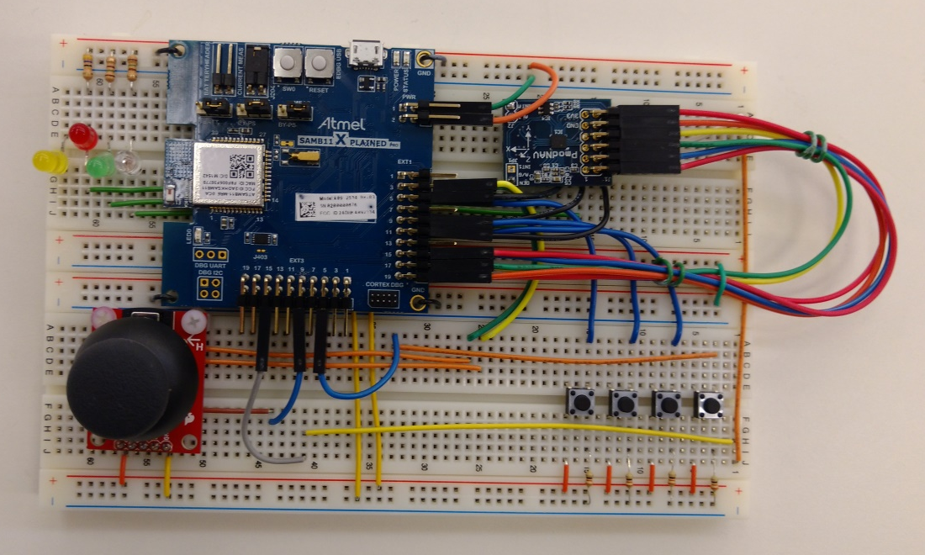
Figure 16: Revised Alpha model

4.3 Test Results

4.3.1 Distance
One of the main use cases for the CyMote is to be dropped from the third floor of the Coover atrium, a distance of 28 feet. This is the maximum distance the CyMote needs to be from a computer and still functional. We tested our CyMote outside with a direct and unobstructed line of sight and found it held a connection up to 160 feet away. This is more than enough distance for our requirements. We also tested connectivity in the atrium and had no problem communicating over BLE in that environment.

4.3.2 Throughput
The CyMote needs to transmit data at a rate that is useable by students. Dr. Daniels determined that the minimum wireless data transmission rate needs to be one transmission every 30 milliseconds, or about 33 transmissions per second. We were only able to achieve 1.5 transmissions per second. This is drastically slower than the required speed and is due to our decision to use BLE instead of classic Bluetooth. BLE trades transmission rate for lower power consumption, and we were not aware of this when we designed our board around it. We have enough unused GPIO that another group could easily add a Bluetooth circuit to the design, and that would solve the data transmission issue.

4.3.3 Multiple BLE
It will be normal for multiple CyMotes to be transmitting data in close proximity to one another. We must be sure that they will not interfere with one another and there will not be a significant slowdown of transmission speed. We tested three ATSAMB11s loaded with code that would allow them to transmit some kind of data. Because we did not have three CyMotes built, we had two XPlained Pros streaming dummy data, and one working CyMote streaming all sensor data. We oriented the CyMote in various positions and observed the accelerometer data. It was determined to be correct; the two dummy XPlained Pros did not interfere. We also found no transmission slowdown from the test. Further testing with more CyMotes is needed to be sure there will be no interference, but our initial findings suggest that this will not be a problem.

4.3.4 Robustness
The CyMote needs to be able to withstand day to day student abuse. Our Beta model, in its case, is able to withstand a drop from desk height onto a tile floor while powered on. Our CyMote also needs to be able to withstand a drop from the third floor of Coover while encased in a soft container. Currently CprE 185 encases their devices in a foam football. Our Beta model, in its case and inside a foam football, was able to withstand the fall from the third floor of Coover while powered on.

4.3.5 Battery Life
We ran a charge test and a discharge test. During the charge test, we connected the CyMote to a USB input from a computer and allowed it to charge until the MAX8606 stopped the charging process. From a completely discharged battery (2.7V) to a completely full battery (4.2V) it took 27.5 hours. This can be decreased significantly by adding functionality to the MAX8606 chip that would allow it to charge 2-4 times faster.
We ran a discharge test, discharging just over 100mA at a constant rate until the MAC8606 turned the output of the battery off. From full battery to discharged battery took 23.4 hours. 100mA is much more than we expect to use from the current system. However, we are going to leave the battery in place in case there is a change to the board later that would require higher power output.

5 Conclusions
The goal of this project was to lay the foundation for a replacement for the Arduino Esplora in CprE 185. In that respect, we have succeeded. We did not achieve the desired data transmission rate over BLE and have utilized a few workarounds that are not 100% efficient, namely bit banging the SPI interface. When a new senior design group or research group takes over our project they would be wise to implement a Bluetooth circuit. Our design leaves enough open GPIO to implement such a circuit without requiring a massive redesign of the already existing configuration. BLE does not seem suitable for our purpose. We did not research adequately enough to come to this conclusion before we began development and it became too late to redesign.
The device itself gathers the required data, and with the alpha model through a UART connection, is able to show that data on a terminal. We successfully designed and built a PCB that has all the functionality required except for an adequate data transmission rate. The PCB in a case is robust enough to be handled by students, be dropped from the third floor of Coover in a soft container, has a large enough battery to last an entire day of heavy use, a way to recharge, and all necessary I/O and sensors.

6 References
Datasheet for the LSM9DS0: http://www.st.com/content/ccc/resource/technical/document/datasheet/ab/2a/3b/45/f0/92/41/73/DM00087365.pdf/files/DM00087365.pdf/jcr:content/translations/en.DM00087365.pdf
SparkFun LSM9DS0 Arduino Hookup Guide:
https://learn.sparkfun.com/tutorials/lsm9ds0-hookup-guide/basic-arduino-example
Datasheet for the LSM9DS1:
http://www.st.com/content/ccc/resource/technical/document/datasheet/1e/3f/2a/d6/25/eb/48/46/DM00103319.pdf/files/DM00103319.pdf/jcr:content/translations/en.DM00103319.pdf
SparkFun LSM9DS1 Arduino Hookup Guide:
https://learn.sparkfun.com/tutorials/lsm9ds1-breakout-hookup-guide
Datasheet for the ATSAMB11:
http://www.atmel.com/Images/Atmel-42426-SmartConnect-SAMB11-SOC_Datasheet.pdf
Datasheet for the X-plained Pro Development Board: http://www.atmel.com/Images/Atmel-42664-ATSAMB11-Xplained-Pro_UserGuide.pdf
Atmel Software Framework (ASF):
http://asf.atmel.com/docs/latest/samb11/html/index.html
Official description of CprE 185:
http://catalog.iastate.edu/collegeofengineering/computerengineering/#courseinventory

7 Appendix

7.1 Operation Manual
To power on the board, flip the switch located on the front. To charge the board, plug in a USB-A cord connected to a power source. When charging, the yellow LED will be lit. When the board is powered on a green LED will be lit. To power off the board, flip the switch located on the front. When the board is powered off, no LEDs will be lit, even if the board is charging.
To student will be using the CyMote with a lab PC running Windows 10. To pair a device with a lab computer, click on the start menu and open the settings window. Navigate to Devices, then Bluetooth. Make sure Bluetooth on the PC is turned on, and make sure the CyMote itself is turned on. Wait for the CyMote to be discovered by the PC.

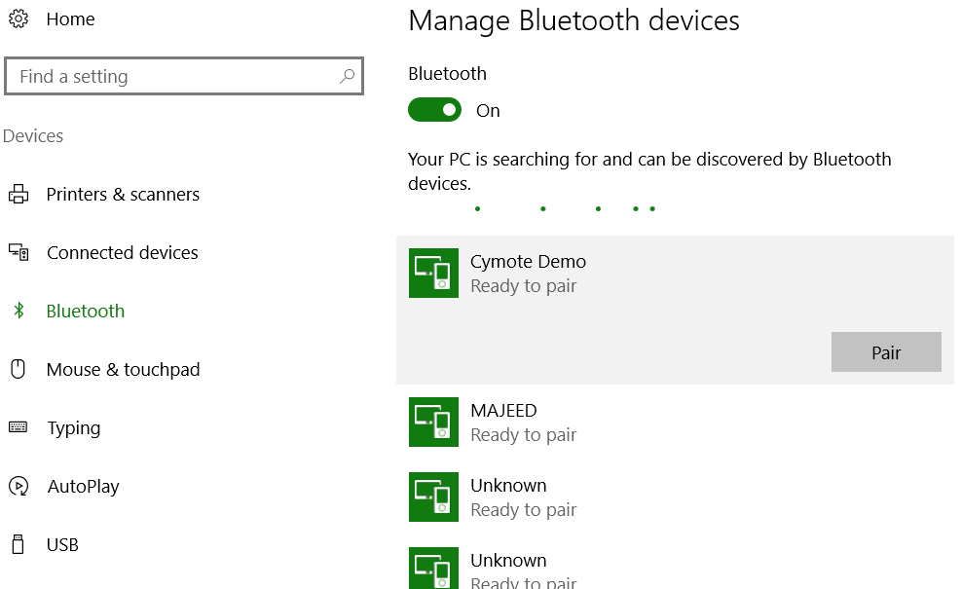
Figure 17: The interface for searching for devices and pairing
If it is not discovered already, this should only take a moment. Click the CyMote device to reveal the pair button, and then click the pair button. If prompted, enter the passcode “123456”. Windows and the CyMote should take care of the rest, and you will have paired your CyMote to your PC, and can now interact with it via the PC Wrapper.
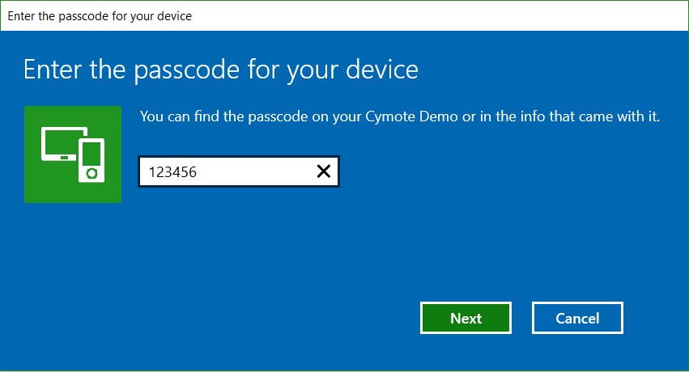
Figure 18: Entering the passcode to connect to the CyMote
The student will interface with the CyMote using the PC Wrapper program, titled explore.exe. This program is meant to be run through the Window’s Command Prompt or through a Cygwin terminal.
In Windows Command Prompt, navigate to the directory explore.exe is located using the “cd” commands. Verify you are in the correct directory with a “dir” command. If explore.exe shows up in the list of files, then the user is in the correct directory and can run the program.
In Cygwin, navigate to the directory explore.exe is located in using the “cd” commands. Verify you are in the correct directory with a “ls” command. If explore.exe shows up in the list of files, then the user is in the correct directory and can run the program.
Note: the following examples will be given assuming the user is running the program in Windows Command Prompt. To run the program in Cygwin, use ‘/’ instead of ‘\’.
To run the program, the user must call the executable with a number of flags. Run the program by typing “.\explore.exe” followed by a number of supported flags. The supported flags include the following:

Flag | Component
t | Time
a | Accelerometer
g | Gyroscope
m | Magnetometer
b | Buttons
j | Joystick
Figure 19: Acceptable flags for the PC Wrapper
The flags are entered in one group following the call to the wrapper. For example, if you were to run the wrapper with only accelerometer data, you would call “.\explore.exe –a”. If you were to run the wrapper with accelerometer, gyroscope, and magnetometer data, you would call “.\explore.exe –agm”. These flags can be called in any order, but their order of appearance on screen will be consistent. Therefore, the following calls produce equivalent results, “.\explore.exe –agm”, and “.\explore.exe –mga”.
On screen the data is ordered as comma separated values in the following order: time, accelerometer X axis, accelerometer Y axis, accelerometer Z axis, gyroscope X axis, gyroscope Y axis, gyroscope Z axis, magnetometer X axis, magnetometer Y axis, magnetometer Z axis, button 1, button 2, button 3, button 4, joystick button, joystick X axis, joystick Y axis. All three axes are provided on a call to any of the nine degrees of freedom components. For example, is impossible to get just X axis data from the accelerometer; the Y and Z axis are always included. The same is true for the buttons and for the joystick. If the flag for buttons is provided, all buttons will be shown, and if the flag for the joystick is provided, both joystick axes will be shown.
To end the program, the user enters CTRL-c.
If a flag is provided that is not supported, or if no flags are provided, a usage message will be shown and the program will not be run. The usage message is as follows “Usage: explore.exe –[agmtjb]”.
To program the board, a TA or project developer must obtain an Atmel ICE debugger and connect it to a PC with Atmel Studio installed, and connect the ICE debugger to the PCB via the SWD connection. The device needs to be on. On Atmel Studio, the ATSAMB11 should be recognized. On the top toolbar, if it is not already selected, you must choose the correct device and programming tool. The correct device is the ATSAMB11 and the correct programming tool is Atmel ICE SWD. To program the board, simply open the project you would like to load onto the board and click the hollow green arrow in the toolbar, “Start without debugging”. Atmel Studio will take care of the rest.

7.2 Alternative Designs
We have discussed in length the process we went through in regards to the Alpha Model and the Beta Model. The Beta Model, however, experienced some significant changes of its own. They are signified by their suffixes: 1.0, 2.0, and 3.0.

7.2.1 CyMote 1.0
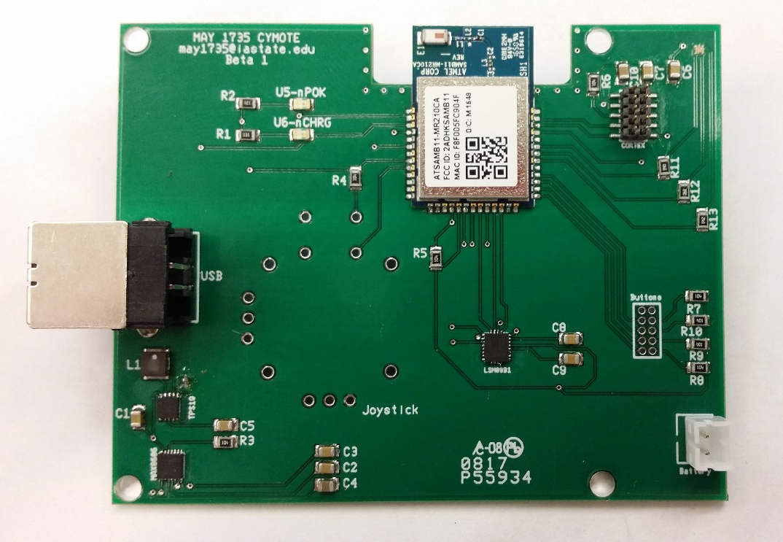
Figure 20: CyMote 1.0
The CyMote 1.o was the very first version that we put together. It included all of the major parts, and the outline of 1.0 stayed until the last revision. We purchased it through Advanced Circuits, and we thought it looked pretty ok. We played some with the silkscreen, but we were not aware how helpful the information would be at this point. We had some issues when the 1.0 came in. The battery header was designed backward, and we had been confused about the voltage regulator. We thought we had ordered a fixed output regulator and had designed the circuit for that. However, we actually had a variable output regulator, and it was holding a consistent 0.5V. This made troubleshooting the rest of the board nearly impossible. We were able to solder in some wires to a couple points on the board and test out how 3.3V affected the circuits.
There was a major issue with this board however. We designed the ATSAMB11 layout based on the Atmel datasheet. On the datasheet, there are several drawings of the pins in the board layout section. There is an issue with one of the drawings, specifically the drawing that has all the pad dimensions on it. The issue is that the pins are labelled backwards. Unfortunately for us, this image is what we used to design the pad layouts in UltiBoard, and so all of the pins were backwards on the chip. Going back, we were able to see that it was definitely a typo on Atmel’s part, but that did not help us at all. The 1.0 was a helpful venture, however, because it taught us how to solder surface mount parts and what some typical problem scenarios would be.

7.2.2 CyMote 2.0
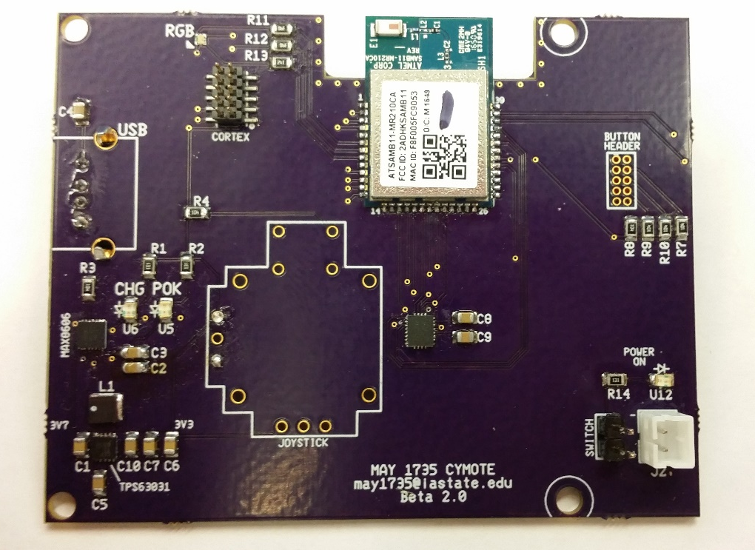
Figure 21: CyMote 2.0
The CyMote 2.0 is best described by its differences from the 1.0 version. We added a header pin for a power switch so the battery could be left plugged in at all times without draining, and we added a LED so the user could know when the switch was ‘on.’ We redesigned the entire voltage regulator layout to better fit the manufacturer’s best practice layout. We flipped the pins on the ATSAMB11, and in the process we had to move several of the other devices to make the traces (which were already tight) align to fit in the space. We moved the button header resistors out of the way of where the button header was going to fit.
We also added more silk screen images. We put an outline around the joystick and added diode drawings to show current direction. We also added silkscreen around the bolt holes to make sure that no parts were too close. This version also saw the change from a USB-B connector to a USB-A connecter in order to be able to fit the plug into the box. However, the datasheet for the type A connector was confusing, and the holes were designed backwards, which is why you can see that the USB connector on the CyMote 2.0 is underneath the board. And lastly we widened the traces where large current flows to avoid internal resistance.
The other thing we did at this time was begin segregating the documentation from Version 1.0 and Version 2.0. This way we were able to trace back any issues to their origin, and we were able to better document how the project was progressing.

7.2.3 CyMote 3.0
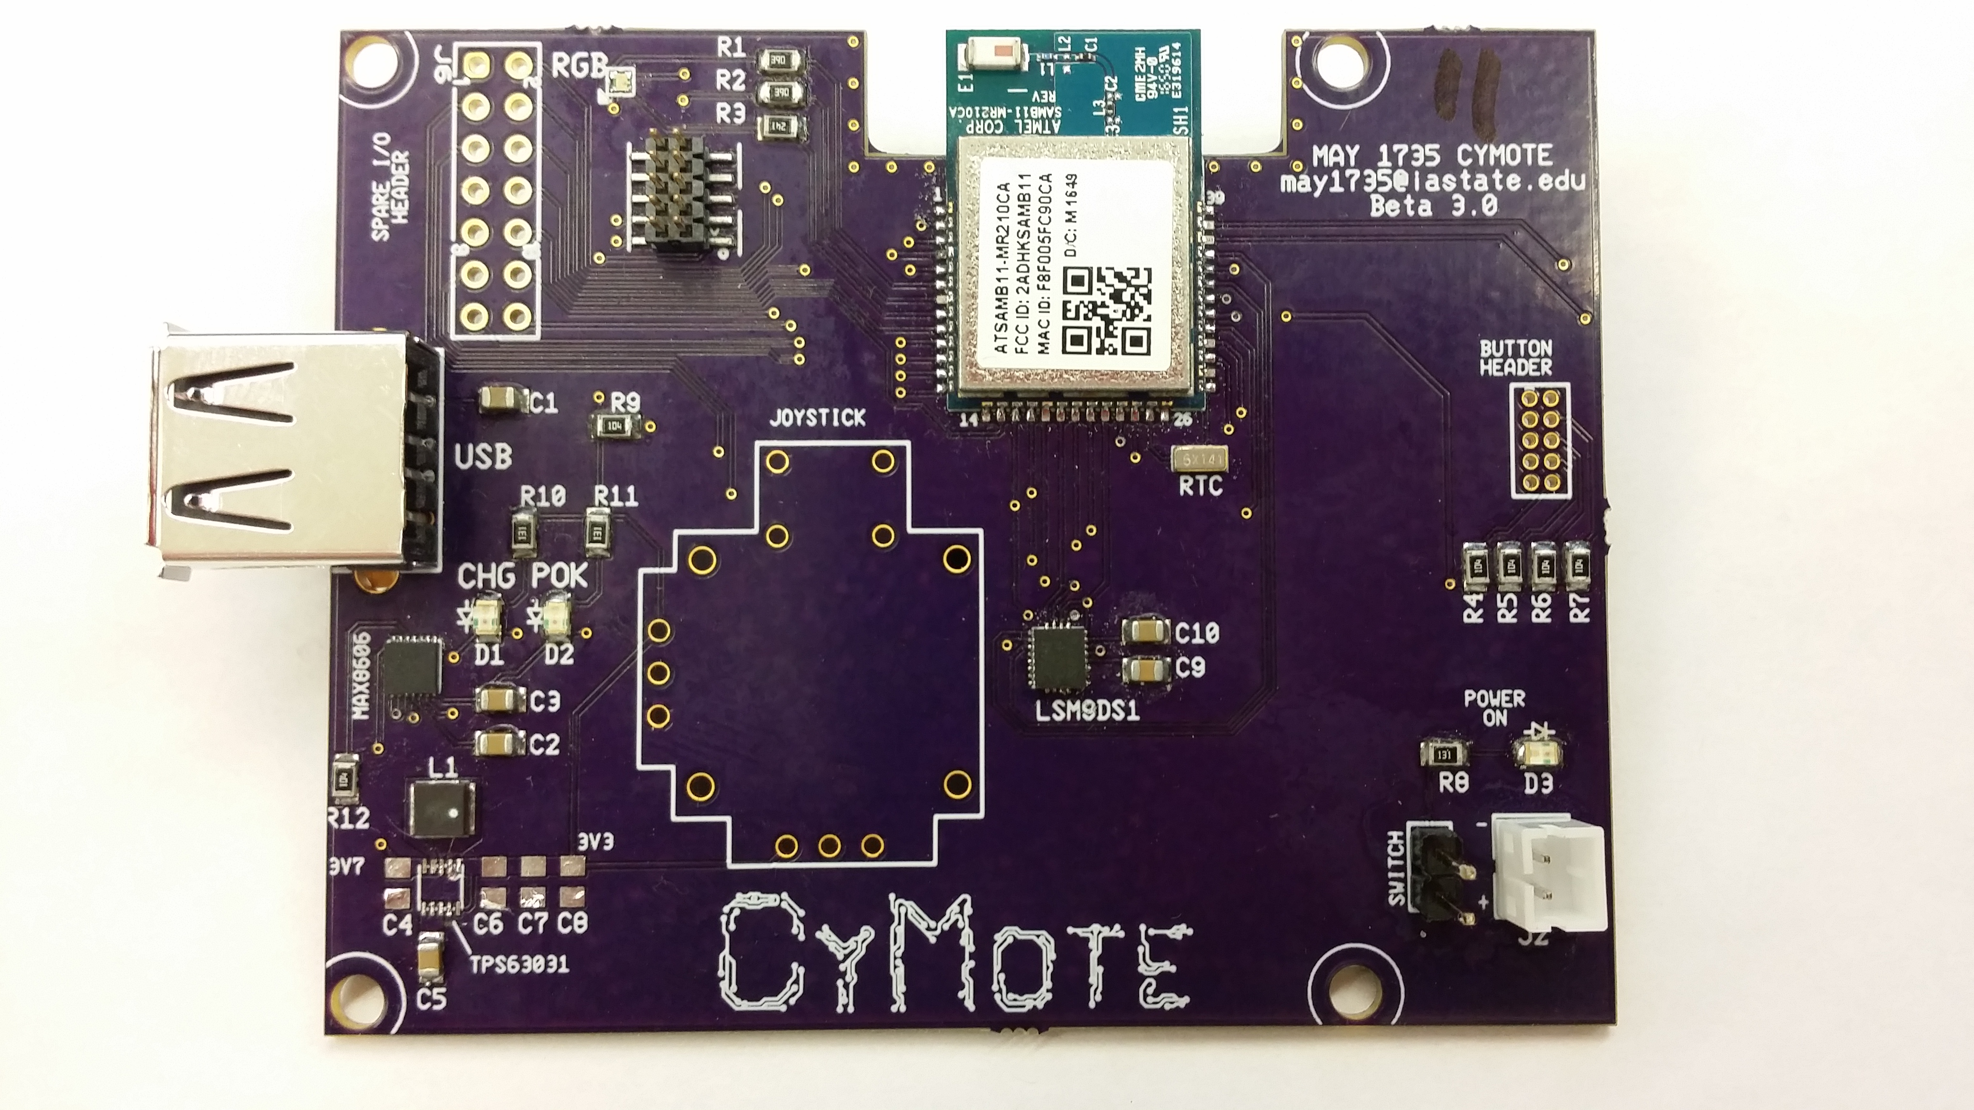
Figure 22: CyMote 3.0
This is our presentation iteration. It incorporates all the changes that we saw fit to correct and has our fun new logo on the silk screen. The layout is very similar to the 2.0, with only minor changes to the locations. The USB and button headers were moved closer to the edge of the board to allow more room in the middle. The 3.0 fixed a major issue with the 2.0: the addition of a necessary external real time clock crystal. The RTC just below the ATSAMB11 is a 32.786kHz crystal that affects the programming of the whole system. Without this, even though we could successfully program to the board over the SWD interface, the BLE would never have worked.
The other major chance we made in this version is the spare I/O header. We took every spare pin from the ATSAMB11 and ported it to this header. This will allow future users to attach new devices to the CyMote, and because of the ATSAMB11 MEGAMUX, you can access any of the communication buses from these pins.

7.2.4 CyMote Next Gen
We have some suggestions for the next generation of the CyMote, as we hope there will be one.
- Creation of an accurate 3D model. We were able to generate some CAD files, but we did not have time or expertise to put them together and do something useful with them. It would be very helpful for the project if someone could merge these files and do the necessary calculations about what the hole sizes needed to be and where they will go.
- New power switch and user buttons. The buttons and switch we have now are good enough to work, but are not clean or important. Someone could spend some time sourcing and designing a new setup.
- Adjust the charging speed. The charging speed is variable on the MAX8606, and so someone could put DIP switches on the board to allow a user to set the charge speed at 100mA, 200mA, 500mA, or any variable speed by designing a voltage divider.
- Adjust the SPI bus from the LSM9DS1 to the ATSAMB11. Currently it is using two MISO wires, and it could be using just one.
- Change the circuits for the charging status LEDs. The current setup has the LEDs being powered by the 3.3V rail, which is not activated if the power switch is off. It should be changed to the MAX8606 output, which will be on any time the battery is connected with enough charge, or if the USB is plugged in.
- Put a shrouded headed on the Cortex header. This needs to be done when the developer is 100% sure they know how they’ll connect to it.
- *Big Project* Find and implement a USB to SWD/UART/SPI gateway. This way the CyMote could be programmed from the USB port instead of/as well as the Cortex header. This would/should make the whole system much easier to access.

7.3 Other Considerations
These are stories about our process and how we came to the conclusions we did. They are meant to inform and illustrate what work we did to get to our finished product.

7.3.1 Bluetooth Low Energy (BLE) vs. Bluetooth
One of the requirements for our project was that our new device had to be wireless. To the electrical engineers that meant they had to figure out a way to charge the device and run the device with minimal energy consumption. To the computer engineers this meant they had to communicate between the device and the computer wirelessly.
After doing some research and drawing from past lab experiences, we thought that Bluetooth would be the answer to our problems. During our research we found that Bluetooth has a low energy standard, Bluetooth Low Energy (BLE). This standard trades data throughput for energy by not transmitting as fast or as often. This seemed great but our advisor warned us that BLE might be too slow. We found a processor that had BLE integrated into it so we would not have to worry too much about the BLE paraphernalia and decided that if it was too slow, we could use some extra GPIO to include a regular Bluetooth module.
We thought that communicating over BLE would be as simple as communicating over classic Bluetooth. Turns out, it kind of is and it kind of is not. BLE uses a tree hierarchy to organize itself into a top level profile, a list of services included in the profile, and a list of characteristics associated with each service. A common example is a heart rate monitor. The heart rate monitor is the profile and it has a heart rate service and a battery service. The heart rate service has characteristics about the heart rate, next checkup date, blood pressure, etc. and the battery service has characteristics about percent charged. The characteristics are the only items that contain data, the profile and services just contain information about what is in the level below them.
It sounds like using BLE is easy, and once we understood how to use it, it was. The problems came when trying to use the libraries that came with our processor. Now this is not the section on the lack of documentation that we found on Atmel, but that did have a significant effect on the BLE front. It took most of the first semester to understand the libraries and BLE. During the second semester, we completely redid our BLE code to use a separate set of functions. It was very frustrating and a little discouraging.
Once we got BLE working, we realized that we lost sight of our throughput requirement. The original plan was to get Bluetooth up and running in the first semester, and if it was not quick enough, add in a regular Bluetooth module during the second semester. Since it took so long to get BLE working properly, we had run out of time to include the module. We decided to make BLE work as quickly as we could and consulted our advisor again for some help. We showed us how to pack the data efficiently which speed things up but it still was not enough.
In the end we got BLE communication to work as fast as we could. We were not using a lot of energy so our battery life was great. We could communicate wirelessly to a computer. It just was not quite quick enough for our needs though.

7.3.2 Switching from the LSM9DS0 to the LSM9DS1
During development of our Alpha model we used the LSM9DS0 nine degrees of freedom sensor. This sensor fit all the requirements for our final product, and it was the sensor we spent most of our time learning SPI with. We had planned to use this chip on our Beta model as well, until March, when we learned there was a new model of the LSM9D chip: the LSM9DS1. We had to quickly change all of our SPI code and our hardware designs to support the LSM9DS1.
Figures 23 and 24: LSM9DS0 (left) and the LSM9DS1 (right)
The LSM9DS1 uses a different SPI Mode, SPI Mode 0, while the LSM9DS0 uses SPI Mode 1. Because we bit banged our SPI implementation, we had to change the low level functions to support this new mode. The LSM9DS1 also ties the gyroscope and the accelerometer to their own slave select pin and the magnetometer to a unique pin, while the LSM9DS0 tie the accelerometer and magnetometer to one pin and the gyroscope to another.
These changes were unforeseen and caused a small amount of stress for the person in charge of developing the SPI interface between the MCU and the nine degrees of freedom sensor.

7.3.3 Issues with Atmel
One of our initial decisions we had to make with creating this project was choosing a microcontroller manufacturer - we chose to work with an Atmel project due to our previous academic experience with Atmel. The chip we chose from Atmel looked promising as well since it had BLE support natively along with all the GPIO that we needed for our project. However, we did not foresee all the difficulties with using Atmel’s APIs and the development board itself.
Atmel manufactures a development board for the ATSAMB11, named the Xplained Pro, that exposes all of the ports of the MCU to allow for easier prototyping. We quickly found that our boards would frequently have issues even just connecting to our computers and being programmed, leading to several frustrating sessions of restarting both the boards and our computers in an effort to get the interface to function correctly. After getting the boards and our computers communicating, we had to struggle through a cryptic API that would sometimes be only vague descriptions of what variables and functions were. This was especially difficult during the development of the BLE part of our project, which is thoroughly described in the BLE story.
Thankfully, Atmel also provided example code for use cases of each of their peripherals, but as can probably be predicted by now, they were not perfect. One of the example projects given was a simple PWM output program. When we ran the program, no output was created on the configured pins. After many hours of attempting to get the PWM output of the SAMB11 to function at all, we submitted a ticket to Atmel’s support to make sure we did not just have something setup incorrectly and to ask for further guidance on getting the PWM to work. Atmel responded by sending us a newer version of their PWM driver code, meaning that Atmel had released a product that was not fully functional.
Needless to say, if we were going to do our project over again we would definitely choose a different microcontroller vendor.

7.3.4 Developing on Arduino
Instead of developing and debugging the SPI interface to the LSM9DS0/1 through Atmel Studio, much of it was done using an Arduino Uno and the Arduino IDE. Arduino offered their own, easier to use, API for SPI communication. We used that API initially to learn about the communication protocol and to verify the functionality of the chips we had and to get an idea for the data we should expect to receive. We were unfamiliar with the protocol at the time and found Arduino’s tutorials and explanations to be much easier to understand than Atmel’s.
Even after we had verified the functionality of the LSM9DS0/1, we continued to use the Arduino environment to test changes and large feature additions before porting them to the ATSAMB11. Once we had decided to Bit Bang our SPI communication protocol, porting the code became much more trivial, as very few environment specific libraries were used. Arduino uses C, but heavily relies on its own libraries.

7.3.5 The Practicality of Building a CyMote
We knew from fairly early on what kind of things we wanted the board to be able to do. Talk wirelessly, use an accelerometer, and be battery powered. But one of the main storylines of the project is the hard truth of turning these desires into parts that someone can understand, build, and troubleshoot. Coming from a place where neither of our Electrical teammates had ever designed or built a PCB, we knew that it would be a long journey. What did not count on from the beginning is exactly how long and arduous each step of the build would be. We had to choose components, source the components, design a circuit, create a PCB layout that would be feasible, source the PCB, assemble the PCB, and then we had to troubleshoot and test our boards once they were assembled. We learned valuable lessons from each of these steps through the process.
The original design for the project was to create a replica for the Esplora. Unfortunately, this meant that all the low level design choices were left to the team. We spent hours and hours researching MCUs that we could build our CyMote around. We only knew that we wanted it to talk wirelessly and be low-energy and battery powered. This left the door open for a lot of possibilities. We first considered what would be a simple solution because we wanted to allow future users to build and service these boards. There was also some documentation from some people who had tried to work on a similar project. These people had some success with some of the I/O components, so we were able to use their ideas. But they’re MCU was not feasible. We also knew that we wanted the MCU to be an active product that was not going to be obsolete in the next five years.
These constraints were more difficult than it might seem, especially since we do not have any experience designing MCU boards. We settled on the ATSAMB11 and we felt like we were able to achieve most of the things we wanted. We did not know much about BLE, but we felt like it would be ok. Then we were able to say that we could use the LSM9DS0 for our accelerometer because it had proven to work in the past and it communicated over an SPI bus. Now we had our two main components and we needed to power them. We found that there are about ten million choices for batteries, battery chargers, and voltage regulators. We had to know the difference in battery types, how these types are used, what kind of voltage regulator to use with a battery, would the battery charger IC also do voltage regulation, where to physically put these components, etc. There are not so many places online to find an intro to power management that was specific our needs. Most places are either too simple or take many parts of the process for granted. Dr. Tuttle was a valuable asset at this point. He helped talk us through several ideas that were either going to be viable or definitely not viable. We were able to finally cement the parts needed for the power circuit.
Then we had to design a circuit that would use all of these parts together. The only things we had to go off were the datasheets and the example diagrams. And these parts are all much more complicated than: power in, power out. Correct capacitances and resistances must be attached to the correct pins. Each chip has several options for output, or charging level, or variable output, or enable, etc. Saying you want the simplest function is actually a difficult thing to implement, and when you design a surface mount board, it ca not be tested without a breakout board. We were able to get a breakout board for our battery charger, but not for our voltage regulator. That came back to bite us in the end, and with more time and knowledge, we would have liked to verify everything worked together before we designed our PCB. But we did not have enough time or experience, so we plunged on.
We started designing our PCB with some really good advice from Lee Harker. And to be clear, we could probably include the line, “with a little help from Lee Harker” after most sentences from here out. There are a ton of rules of thumb when designing a PCB, and they can be complicated and manufacturer specific. We were not very far into the process when Lee suggested that we create a board to fit a case instead of the other way around, which we did not even know that was possible. We outlined our board and had to take in all the considerations of our parts. The ATSAMB11 has an antenna on board that requires a cutout and vias to reduce EMF disturbance. The switching regulator must also be kept as far from the ATSAMB11 as possible. We needed 3-D space for the USB connector and the buttons for the case, and we had to be able to fit the battery in there. So after taking all of these things into consideration we were able to start working on the board.
PCB design is a well codified task, but there is not a great way to learn it quickly. You have to know general sizes for traces and vias, you have to understand how different vias connect different layers, and you have to understand how to make a copper pour for the ground. All of this was difficult and nuanced to learn. We found out later that just because a company claims that they can make a board with 6 mil traces, it does not mean that they can or will. It took us three iterations to get the board to a place where we could confidently say that we *may* have a working board. Along the way, we learned that sometimes datasheets are not accurate, even those from Atmel. We learned that you can create non-trace style copper areas, but that those come with their own issues. We learned that you can spend three hours tracing back an issue that has nothing you have control over. And we learned that we absolutely can design a PCB in the future now. It was an amazing learning process to be honest.

7.4 Code
Link to GitHub repository: https://github.com/mplinthicum/CyMoteSource
This repository is meant to showcase the code we wrote. There is a link in the README of the repository provided that will direct you to our development repo and instructions on where to find the runnable versions of our work.

7.5 Circuit Documentation

7.5.1 Circuit Diagram
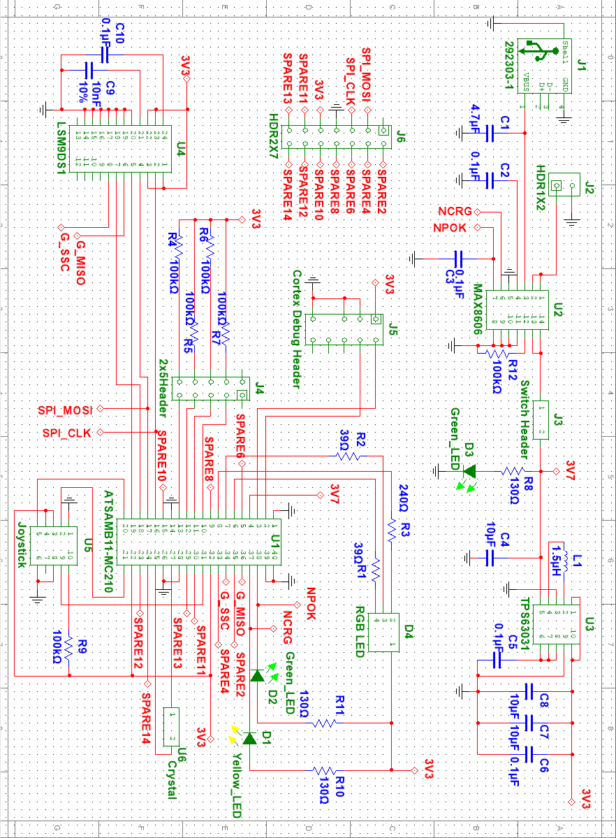

7.5.2 PCB Layout (Copper Top)
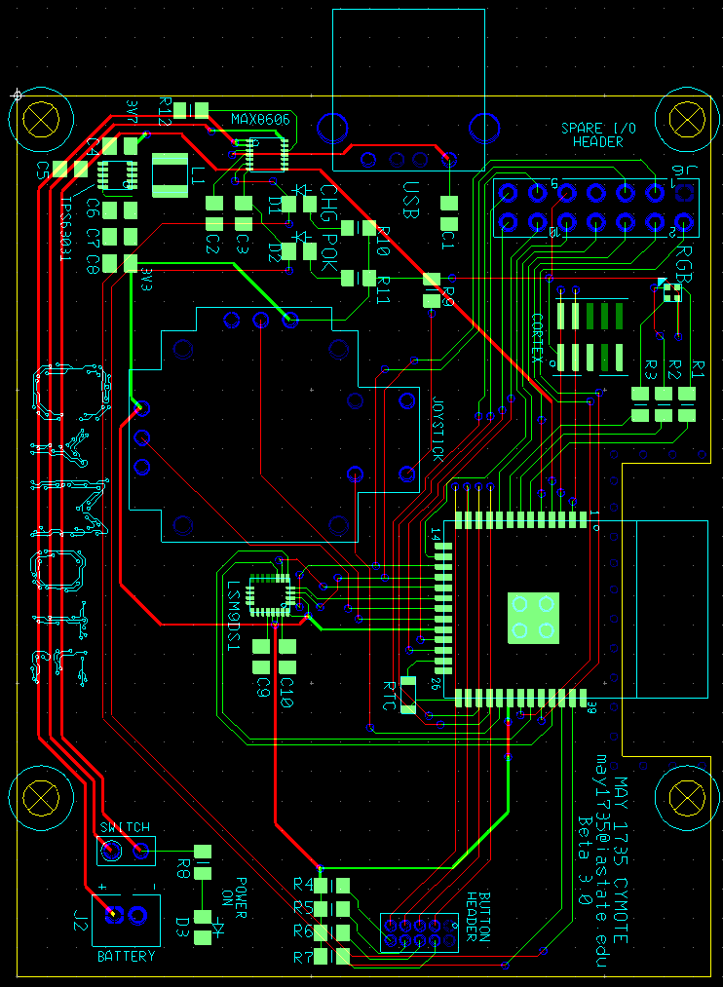

7.5.3 Bill of Materials
